4 Explanatory notes on guideline for operational measures

4.1 Background information to guidelines for operational measures

4.1.1 Ships and loading conditions

4.1.1.1 Five ships were used in the studies: a cruise vessel, a RoPax vessel and three container ships of 1700, 8400 and 14000 TEU capacity. For each ship, 5 loading conditions were selected: 3 loading conditions with small GM values (relevant for parametric roll, pure loss of stability and stability in dead ship condition) and two loading conditions with big GM values (relevant for excessive accelerations).

4.1.1.2 Table 4.1 summarises the parameters of ships and loading conditions, and Figure 4.1 shows examples of the calm-water righting lever curves for typical loading conditions with low metacentric height.

Table 4.1 Ships and loading conditions used in study
Ship | Notation | L_{pp}, m | B_{wl},m | Draft,  GM | Loading Condition:
 |  |  |  |  | 01 | 02 | 03 | 04 | 05
Cruise Vessel | Cruise | 230.9 | 32.2 | d, m | 6.9
 |  |  |  | GM, m | 1.5 | 2.0 | 2.5 | 3.25 | 3.75
RoPax Vessel | RoPax | 175.0 | 29.5 | d, m | 5.5
 |  |  |  | GM, m | 3.7 | 4.5 | 5.2 | 5.9 | 6.6
1700 TEU Container Ship | CV1700 | 159.6 | 28.1 | d, m | 9.5 |  |  | 5.5
 |  |  |  | GM, m | 0.5 | 1.2 | 1.9 | 5.75 | 6.75
8400 TEU Container Ship | CV8400 | 317.2 | 43.2 | d, m | 13.93 | 14.44 | 14.48 | 11.36
 |  |  |  | GM, m | 0.89 | 1.26 | 2.01 | 5.0 | 6.93
14000 TEU Container Ship | CV14000 | 349.5 | 51.2 | d, m | 14.5 |  |  | 8.5
 |  |  |  | GM, m | 1.0 | 2.0 | 3.0 | 9.0 | 12.0

Figure 4.1 Calm-water righting lever curves for typical loading conditions with low GM

4.1.2. Preparation and approval of operational measures and sources of weather data

4.1.2.1 An important question is in what phase of ship life cycle operational measures should be produced and approved: in design phase, in port before departure or directly en route.

.1 The first option, pre-computation and approval in the design stage, allows using most comprehensive numerical tools and statistical procedures, qualified staff and dedicated hardware. Besides, this option allows a detailed approval by the Administration. The drawback is that the computations can be performed only for assumed input parameters, most importantly, standard seaway spectra.
.2 The second option, pre-computation before departure from port (by an on-shore provider), allows, in principle, using comprehensive numerical tools and statistical procedures together with qualified staff and dedicated hardware and, in addition, most accurate data about loading condition and the most actual weather forecast available. In principle, operational measures can be verified by the port Administration together with the weather forecast, but this requires development of a corresponding infrastructure. The drawback of this option is the possibility of unforeseen delays in the ship operator time schedule.

.3 The third option, real-time computations during operation, means performing the required computations during operation (on board or on-shore), once accurate weather forecast is available. It allows using the most actual weather and loading condition data. However, when this approach is followed, both numerical tools and statistical procedures employed have to be significantly simplified, so that the advantage of more accurate weather data may be to some degree compensated by the reduced accuracy of numerical tools and statistical procedures.

4.1.2.2 Note that when the last option is used, accurate weather forecast and operational guidance (or operational limitations) should be ready in a sufficient time before storm (proposal: 3 days) to allow for route change if safe operation in the foreseen storm is impossible (i.e. if there are no suitable speed-course combinations), taking into account that operational guidance or operational limitations are expected to be required usually for loading conditions that are found vulnerable to stability problems.

4.1.2.3 The following sources of environmental data are suitable:

.1 wave scatter tables for operational restrictions but not for operational guidance or operational limitations; and

.2 weather forecast for operational guidance or operational limitations.

4.1.2.4 A wave radar provides recommendations only for the instantaneous environmental conditions, thus it seems unsuitable for operational guidance within SGISC (i.e. to provide operational recommendations for loading conditions vulnerable to stability problems), which, however, does not prevent its complementary use to the SGISC instruments.

4.1.3 Preparation and approval of operational guidance in design phase

4.1.3.1 A drawback of option 4.1.2.1.1, pre-computation and approval of operational guidance in the design stage, is that it relies on assumed theoretical wave energy spectra and therefore, deviations of real seaways from this assumption may lead to erroneous operational recommendations. Especially critical situation in this respect is the cross sea, when wind sea and swell have significantly different directions.

4.1.3.2 One relevant consideration is that the influence of swell is usually noticeable in small to moderate sea states and relatively small in strong storms (which are dominated by wind sea). Figure 4.2 shows theoretical relationship between wind speed and wave height of wind sea (solid line), in comparison with hindcast data for two locations in North Atlantic (,). According to this comparison, the influence of swell is noticeable at small wave heights (indicated by the difference in wave height for a given wind speed between the theoretical relationship and hindcast data) but becomes relatively insignificant in more severe storms. Figure 4.3, showing the significant wave height of swell plotted vs. the significant wave height of wind sea according to the same hindcast data, confirms this.
Figure 4.2 Theoretical relationship between wind speed (y axis) and wave height (x axis), solid line, in comparison with hindcast data for two locations in North Atlantic | Figure 4.3 Significant wave height of swell (y axis) plotted vs. significant wave height of wind sea (x axis) for hindcast data shown in Figure 2

4.1.3.3 To verify this consideration, world-wide hindcast data from the ERA Interim database were used to estimate the likelyhood of severe cross sea. From the data for one year (about 30 million entries), seaways were selected for which the angle between wind sea and swell was more than 80 deg: for about 0.01% of all data, the heigts of both wind sea and swell were more than 4 m; for about 0.001% of data, more than 5 m, and for 0.0001% of data, more than 6 m. This means that the likelyhood of severe cross sea is negligible.

4.1.3.4 To check whether numerical simulations using theoretical wave energy spectra can be applied to approximate roll responses to complex measured wave energy spectra, several cross sea situations were selected from the ERA Interim database. For these situations, two questions were investigated: first, what influence has the overlapping effect of wind sea and swell, i.e. how much the combined response to the two separate (wind sea and swell) wave energy systems differs from the response to the total spectrum and, second, how large is the effect of the approximation of the real wave energy spectrum with a theoretical spectrum.

4.1.3.5 To answer these questions, numerical simulations of ship motions in irregular waves were performed for the selected situations for the following modes:

.1 measured wave energy spectrum, including wind sea and swell;

.2 separate wave energy spectra of wind waves and swell, derived from the measured wave energy spectrum. The responses (rate of stability failures) to these two separated spectra were summed; and

.3 approximated wave energy spectra, separately for wind waves and swell. JONSWAP wave energy spectrum with the peak enhancement factor 3.3 and cos² wave energy spreading with respect to the mean wave direction was used for approximation. The responses (rate of stability failures) to the separate theoretical spectra were summed.

4.1.3.6 In the definition of the separated wave energy spectra of wind sea and swell from the measurements, the significant wave height, mean period and mean direction of the wave energy spectrum, wind sea spectrum and swell spectrum were kept unchanged. The ship course was varied from 0 to 360 deg every 10 deg. Numerical simulations were performed for 200 realisations of each seaway until the first exceedance of 40 deg roll angle.

4.1.3.7 This comparison was performed for all ships and loading conditions listed in Table 4.1, for six forward speeds equally distributed between zero and full speed in calm water. Here, selected results are shown for two situations, Table 4.2, for 1700 TEU container ship in loading condition LC01 and 14000 TEU container ship in loading conditions LC01 and LC02.

Table 4.2. Parameters of wave energy spectra for two situations
Situation | A | B
Significant wave height, m
total | 9.8 | 8.7
wind sea | 4.0 | 5.4
swell | 8.9 | 6.8
Mean wave period, s
wind sea | 12.4 | 9.0
swell | 10.9 | 14.3
Mean wave propagation direction, deg
wind sea | 60 | 213
swell | 153 | 27
shift | 93 | 186

4.1.3.8 The results in Figure 4.4 (situation A) and Figure 4.5 (situation B) show that the separate simulations for the wave energy spectra of wind sea and swell and summing the resulting rates of stability failures (compare the left and middle columns in Figure 4.4 and Figure 4.5) leads to slightly non-conservative results, whereas modelling of wind sea and swell systems using a theoretical spectrum (JONSWAP with γ=3.3 and cos² wave energy spreading) leads to slightly conservative results (compare the middle and right columns in Figure 4.4 and Figure 4.5). The total effect due to both separate treatment of wind sea and swell and theoretical approximation of wave energy spectra for these wave systems is slightly conservative in situation A and slightly non-conservative in situation B.

4.1.3.9 In considered all cases, theoretical modelling of wave systems and overlapping their effect (by summing the failure rate corresponding to each of the systems) leads to practically acceptable recommendations for ship’s forward speed and course. Therefore, production and approval of operational guidance in the design phase seems to be an acceptable option.

4.1.4 Probabilistic operational guidance

4.1.4.1 To prepare a database of ship responses, numerical simulations of motions in waves were conducted for each ship and each loading condition in Table 4.1. The simulations were performed for six forward speeds, equally distributed from zero to full speed in calm water, for the zero-upcrossing wave periods T_{z} and significant wave heights h_{s} covering the North Atlantic wave scatter table, IACS Rec. 34, and for wave directions μ from 0 (following waves) to 180 (head waves) deg every 10 deg. For each combination of forward speed, wave period, significant wave height and wave direction, numerical simulations of the duration of 1.7⋅10⁴ hours (or until the first exceedance event) of ship motions were conducted in 200 realisations of the same sea state; the realisations of the same sea state were generated by random variation of frequencies, directions and phases of wave components composing the sea state.

4.1.4.2 From each simulation, the time until the first stability failure was defined. The estimate of the expected time until stability failure was calculated by averaging over N=200 stability failure events as

(4.1)

4.1.4.3 The maximum likelihood estimate of the rate r of stability failures (i.e. number of stability failures per time) was calculated as

(2)

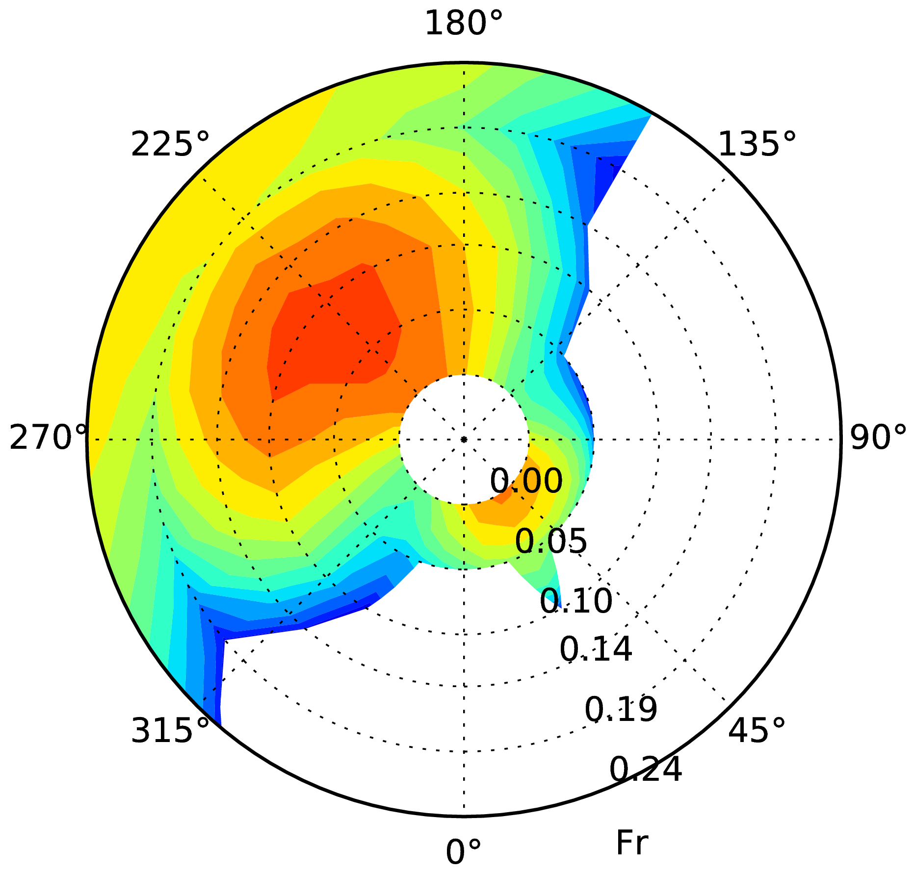 | 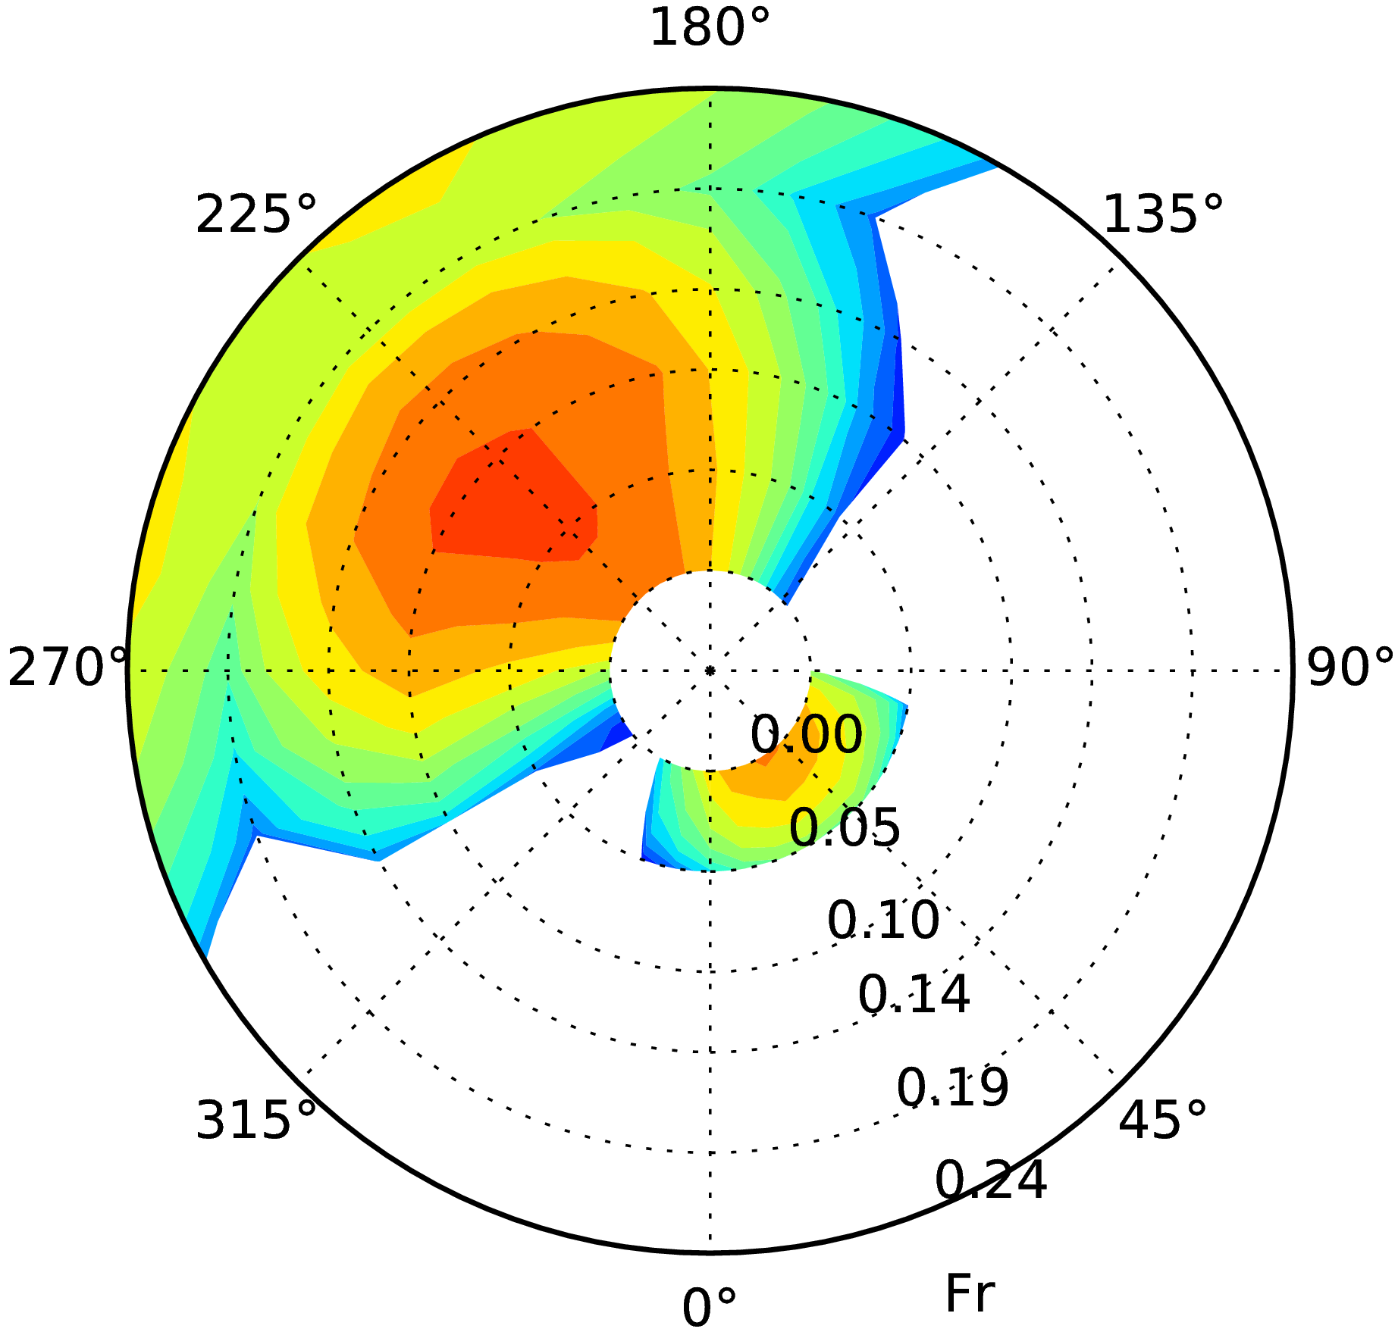 | 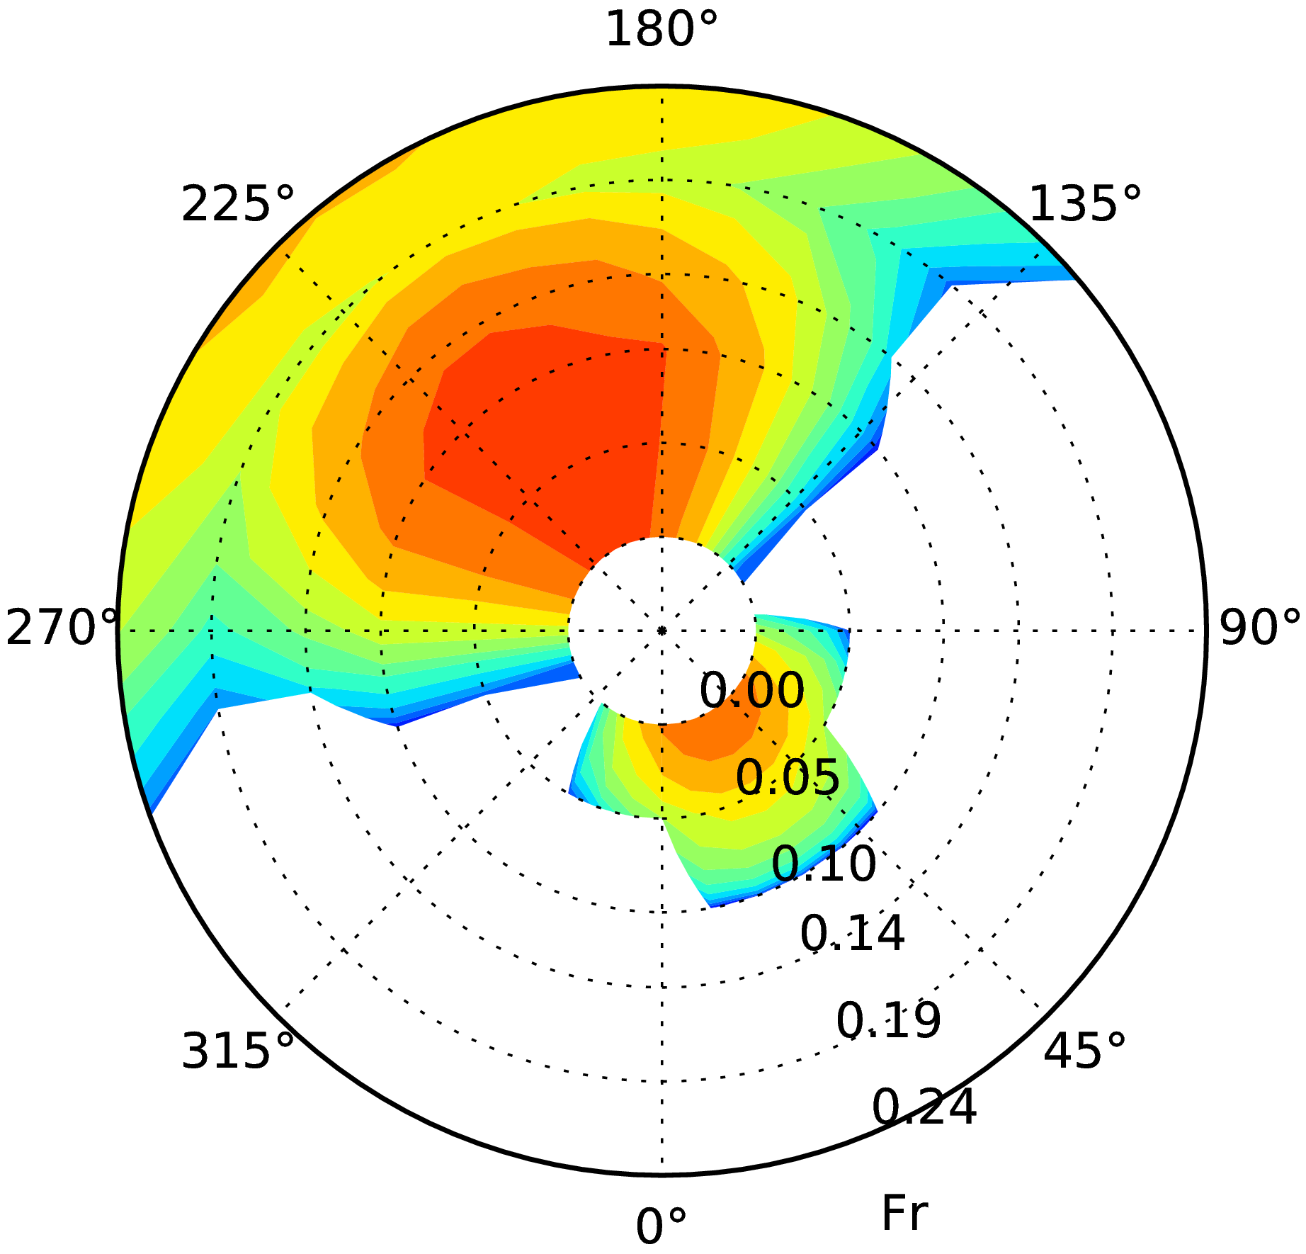
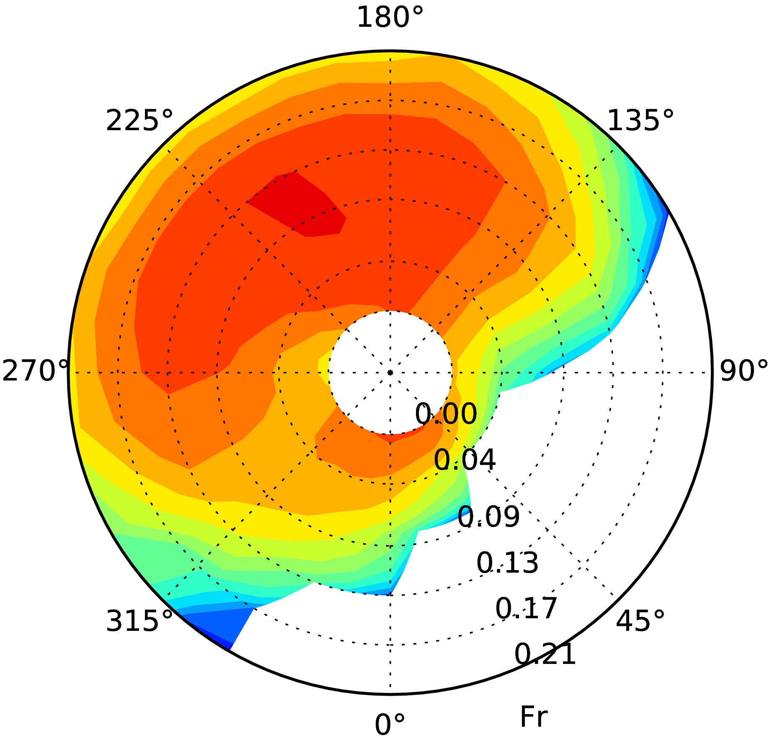 | 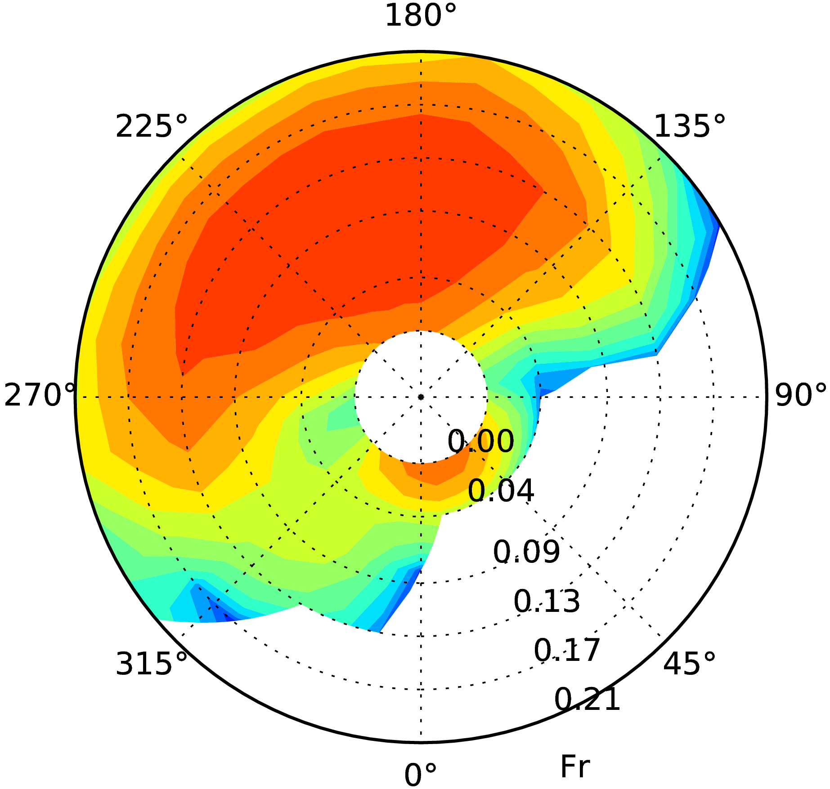 | 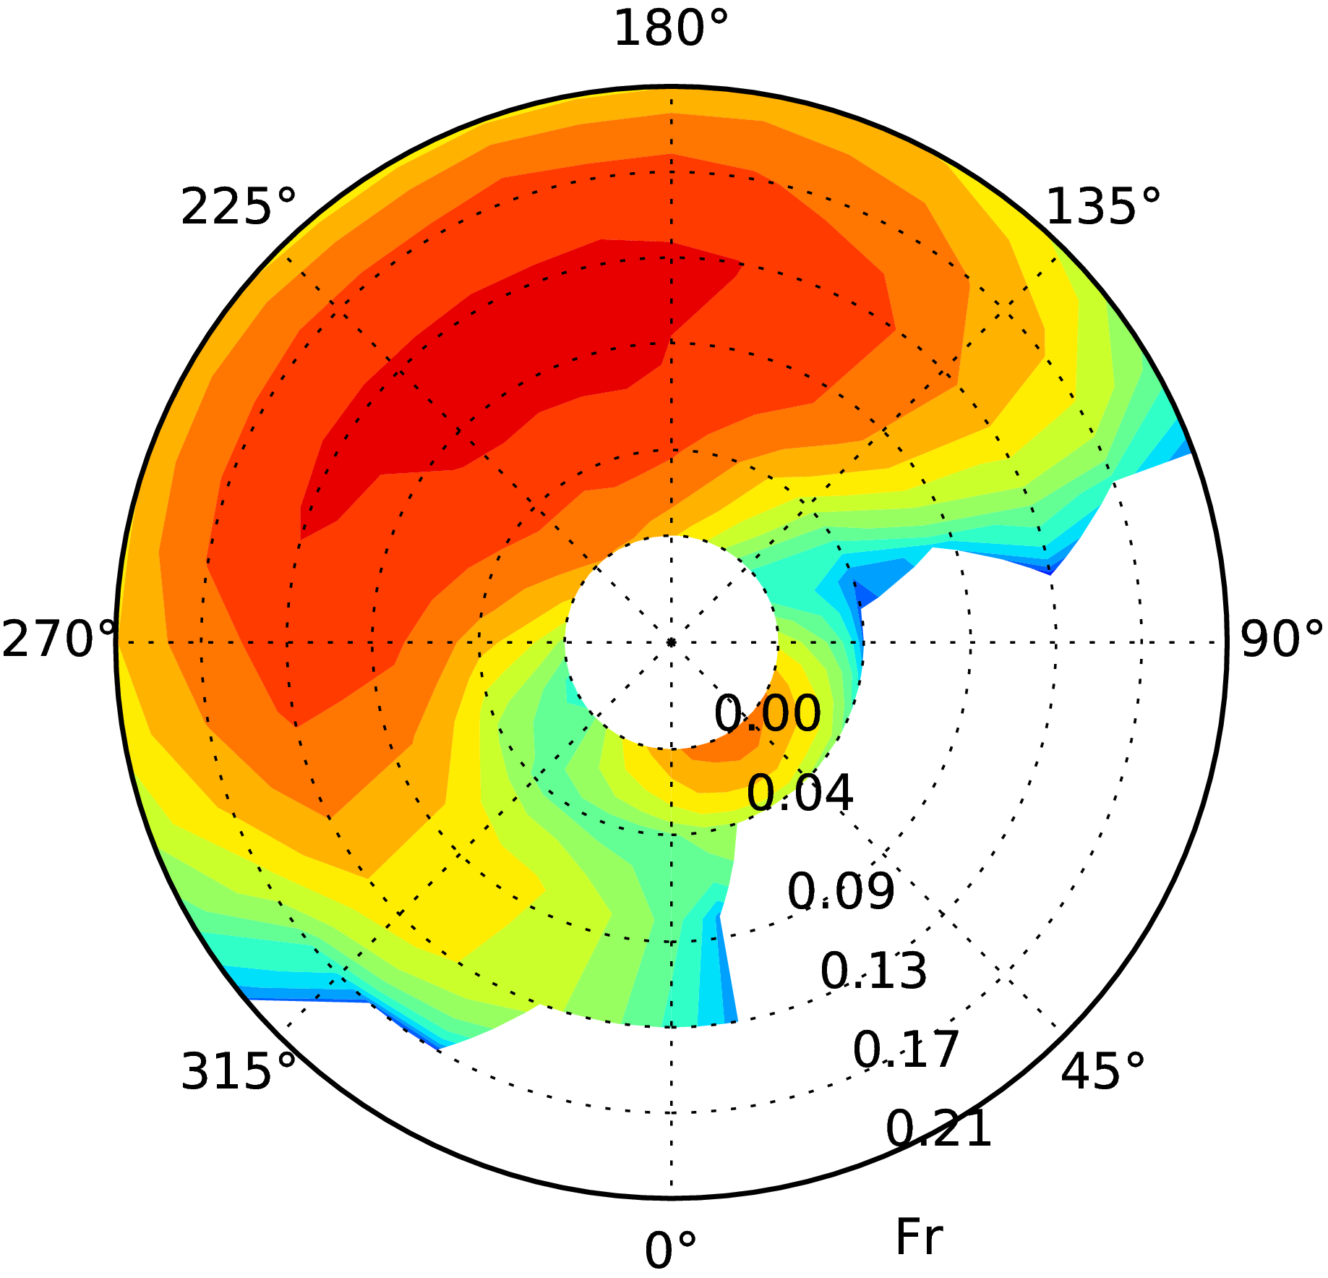
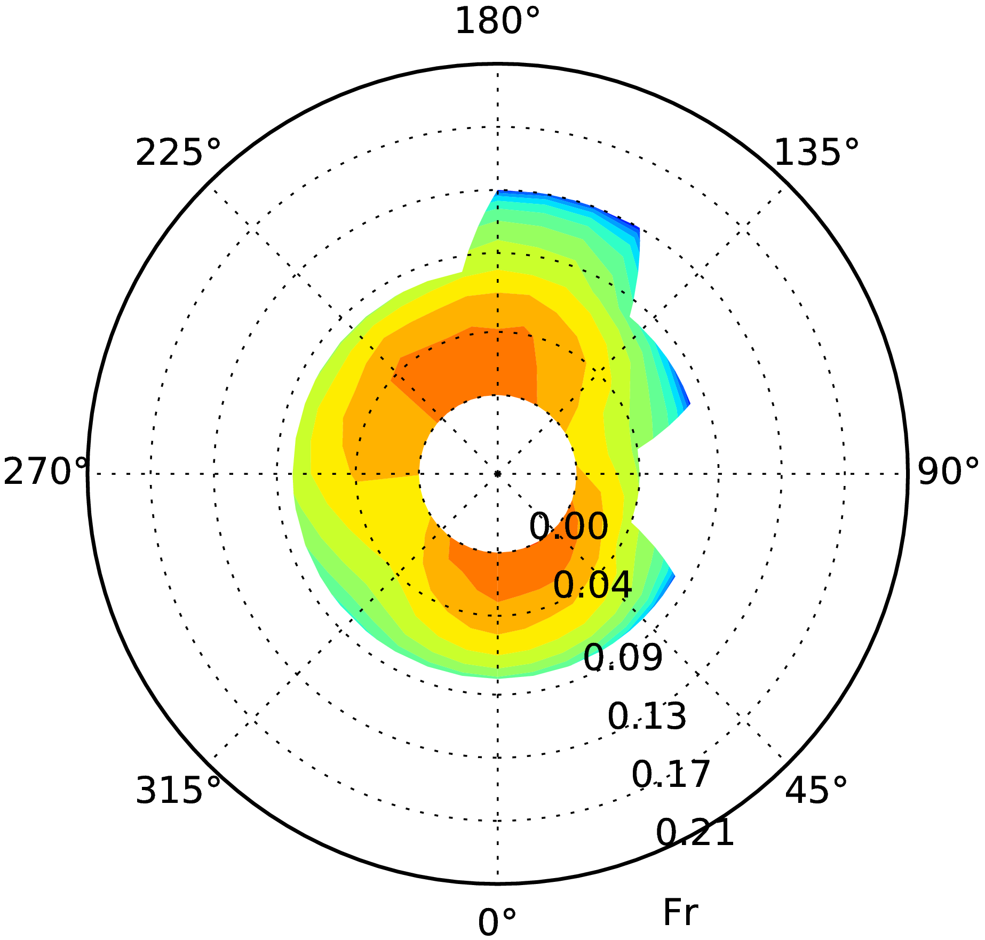 | 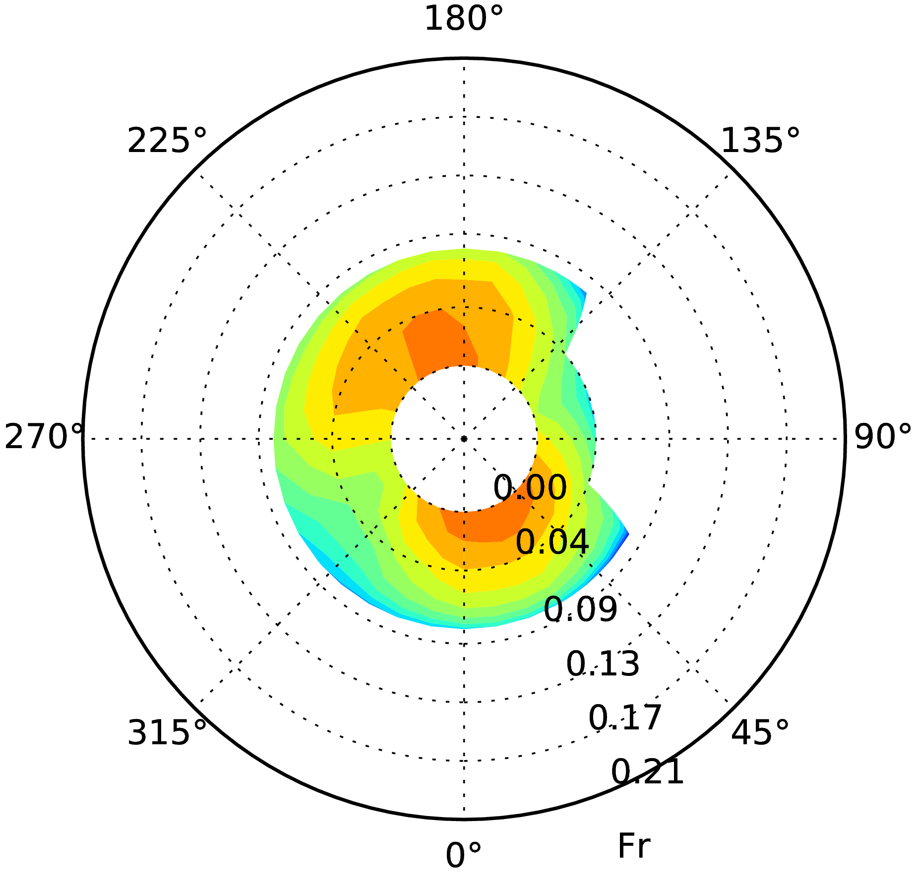 | 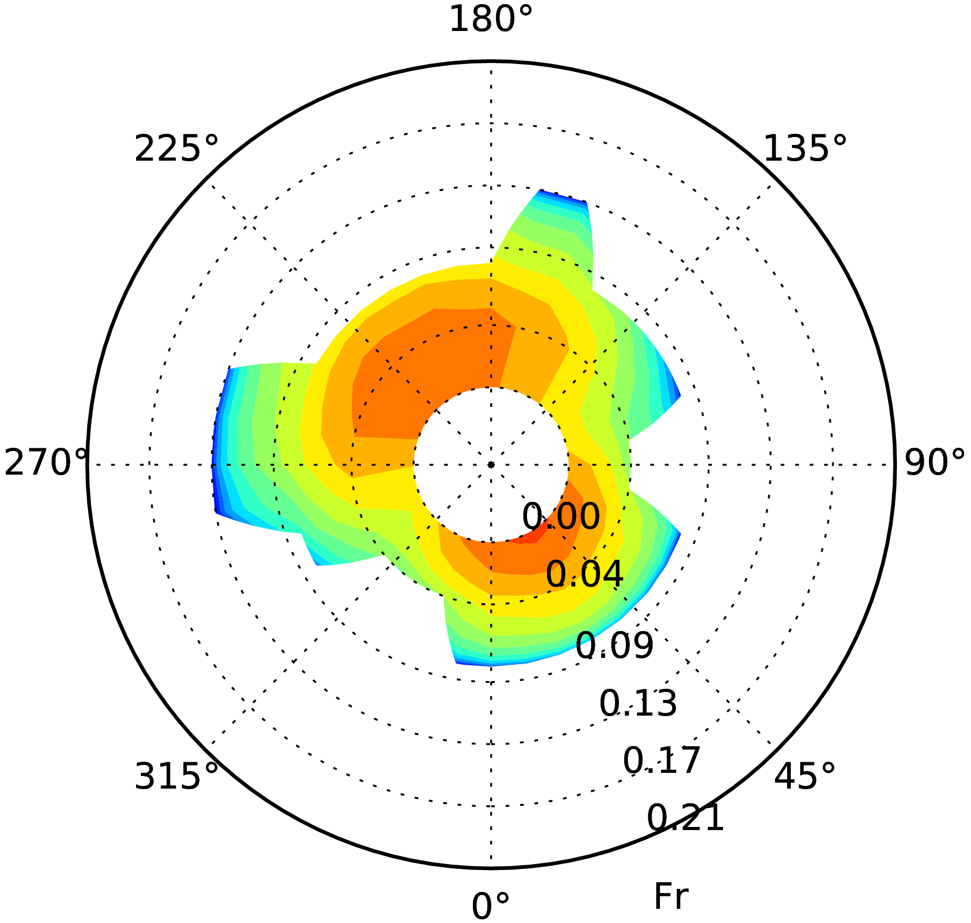
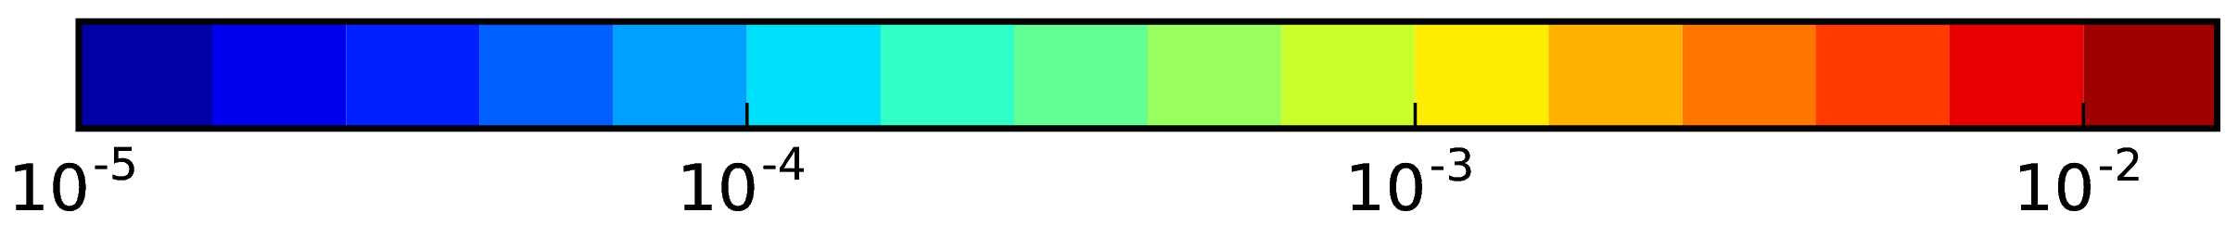

Figure 4.4 Situation A: colour plot of stability failure rate, 1/s, vs. Fr number (radial coordinate) and ship course (circumferential coordinate) for measured wave energy spectrum (left), summed rate for separate wind waves and swell wave energy spectra (middle) and summed rate for separate wind waves and swell wave energy spectra approximated with JONSWAP spectrum with γ=3.3 and cos² wave energy spreading (right) for 1700 TEU container ship in LC01 (top) and 14000 TEU container ship in LC01 (middle) and LC02 (bottom)

4.1.4.4 Operational guidance identifies the combinations of ship speed and course that should be avoided for each sea state, specified by the wave height, period and direction. Obviously, operational guidance (as well as operational restrictions and operational limitations) should be developed in such a way that avoiding these combinations ensures the same safety level as for loading conditions satisfying the Design assessment requirements. To assess the safety level provided by an operational guidance, average stability failure rate was calculated after removing all not recommended conditions. To investigate the depedency of results on the forward speed, different forward speeds were first treated separately:

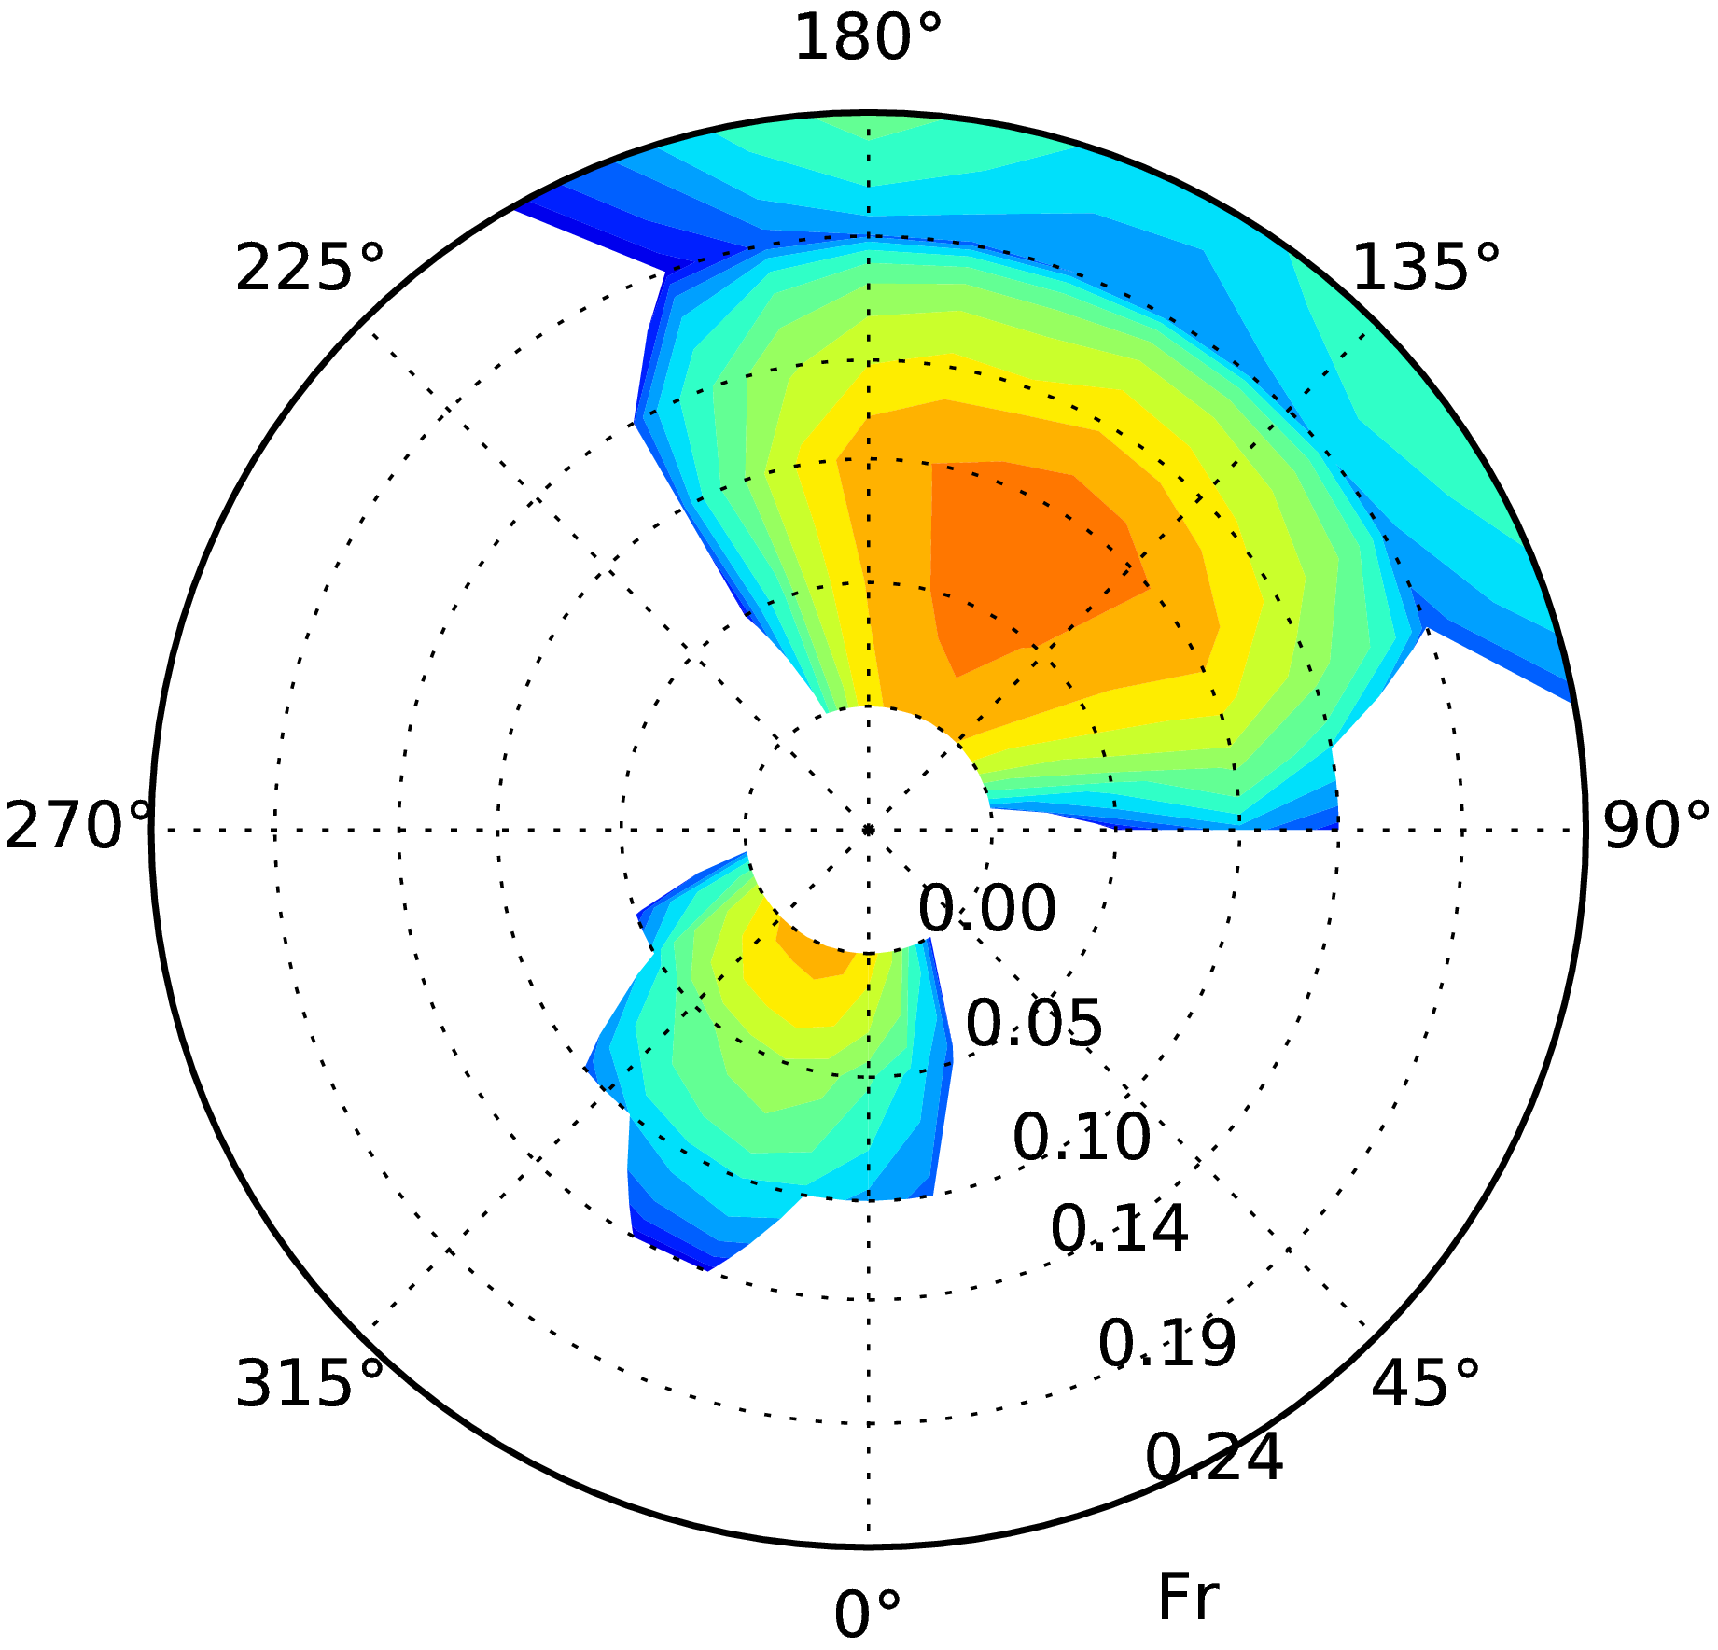 | 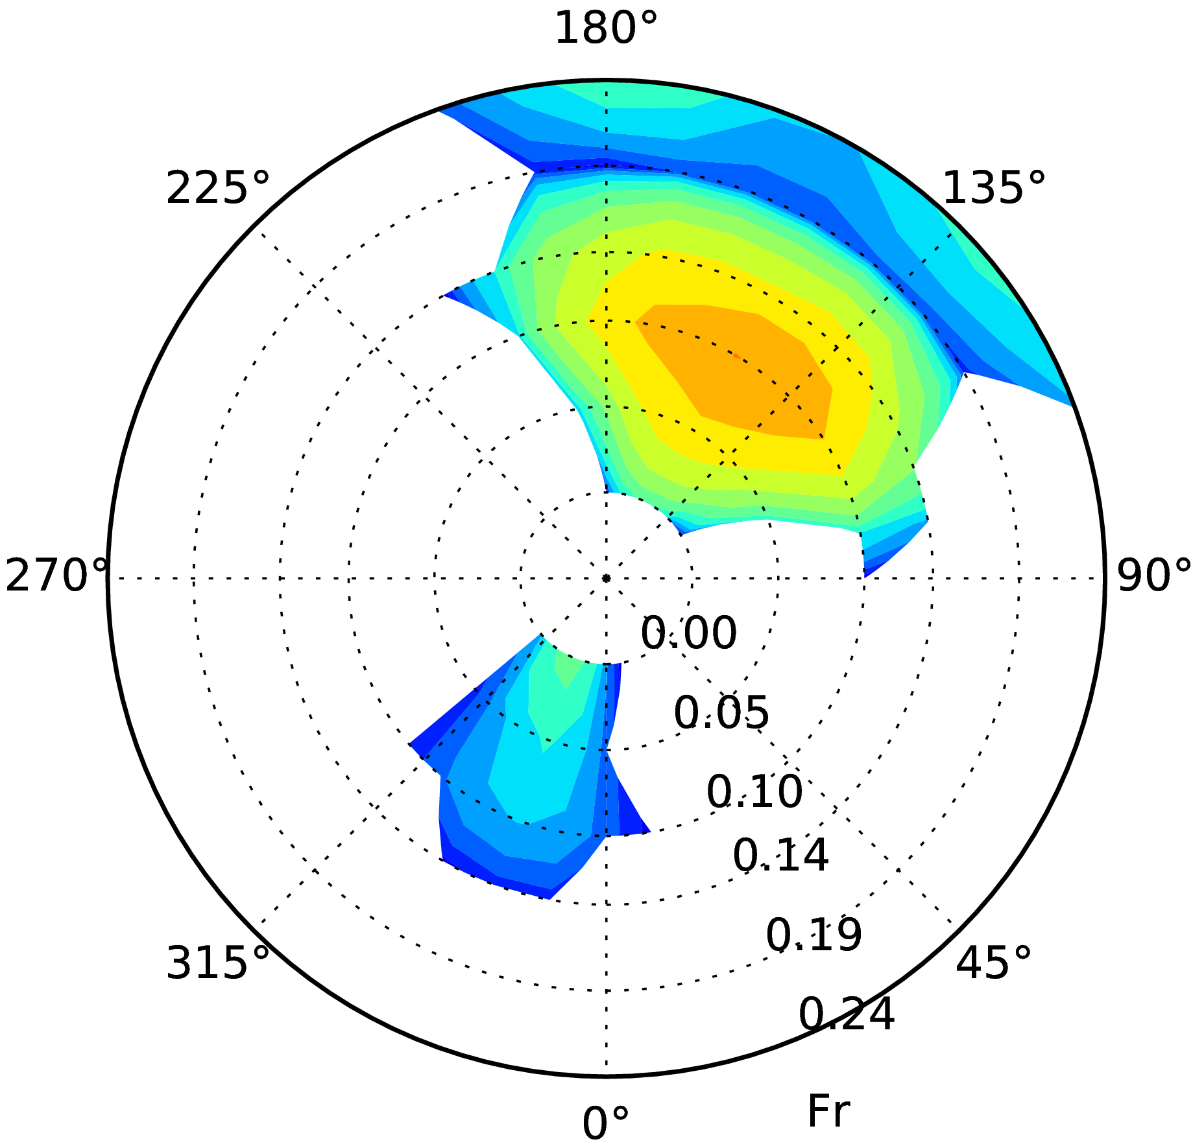 | 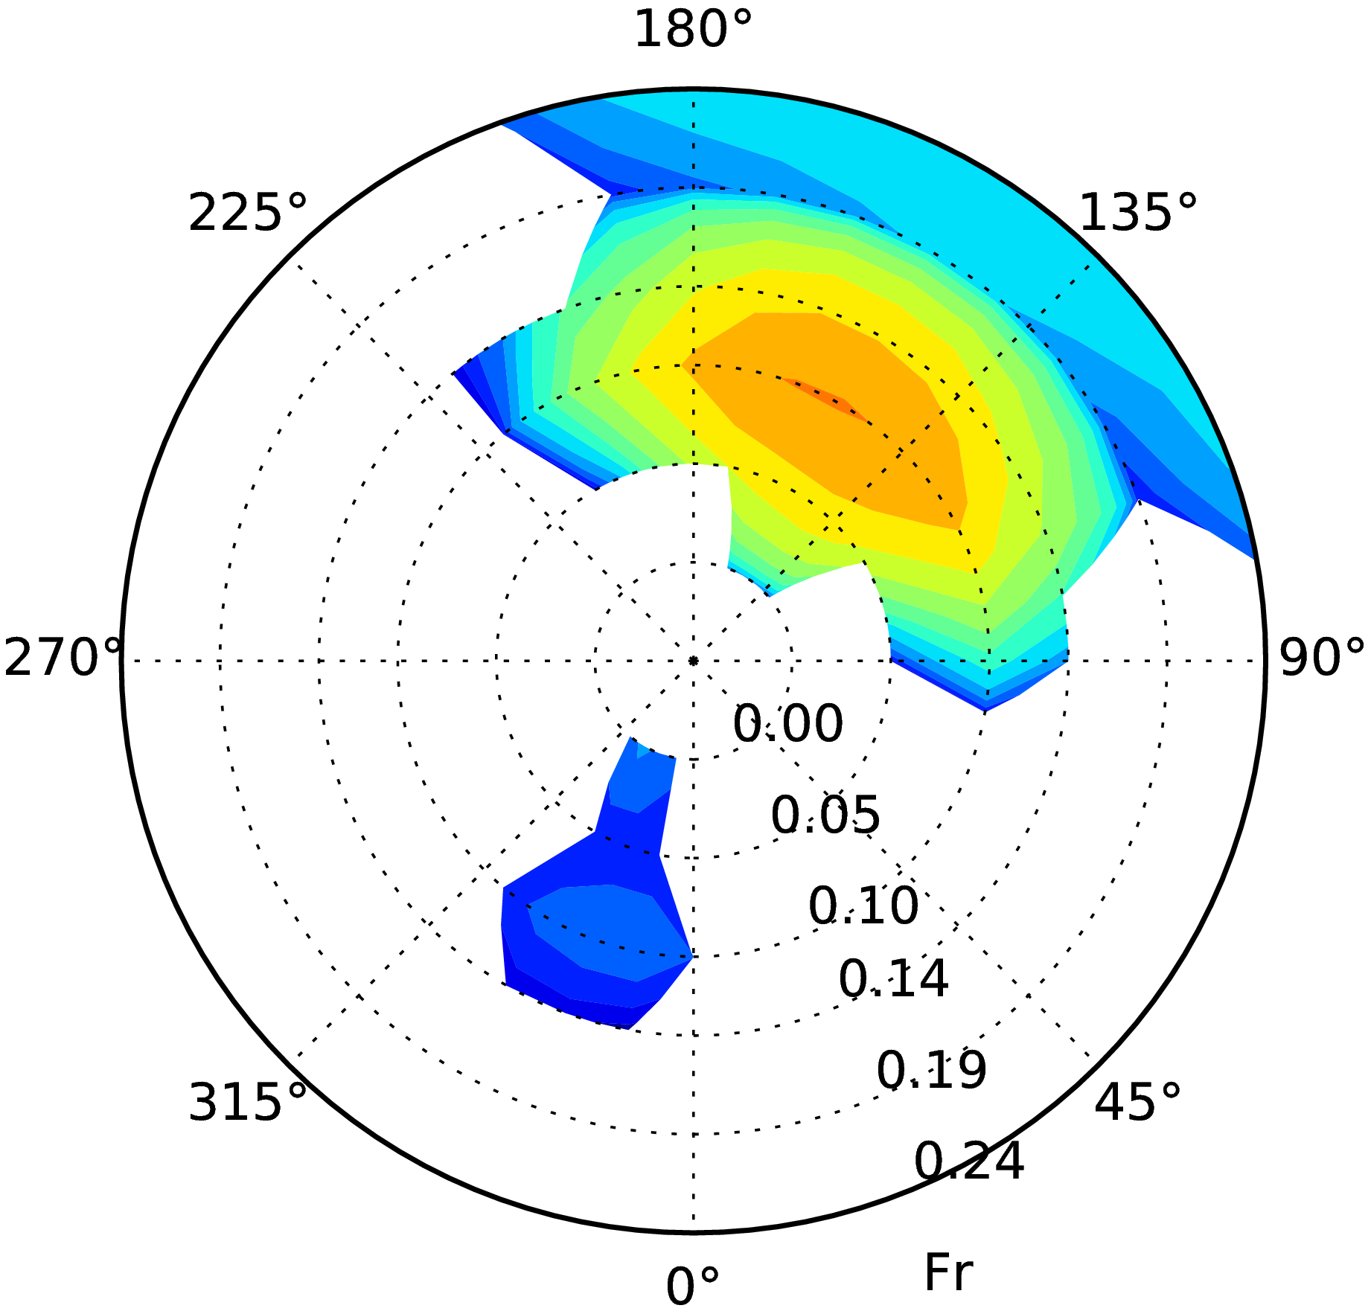
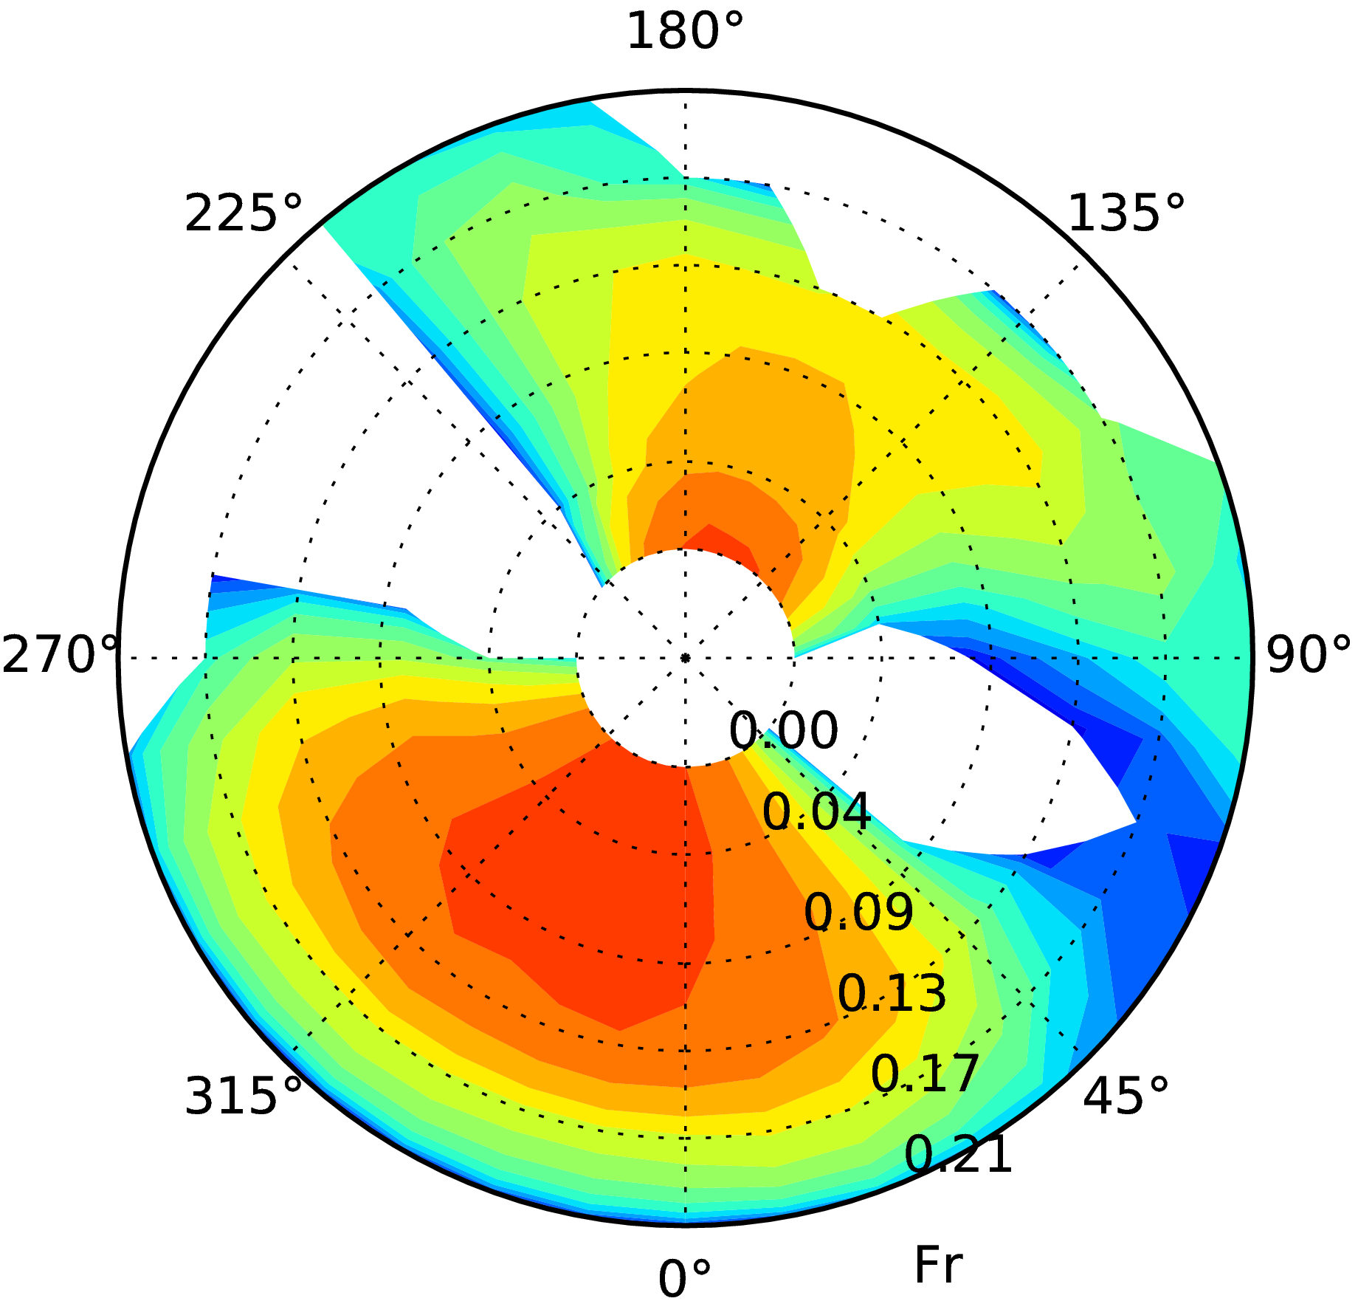 | 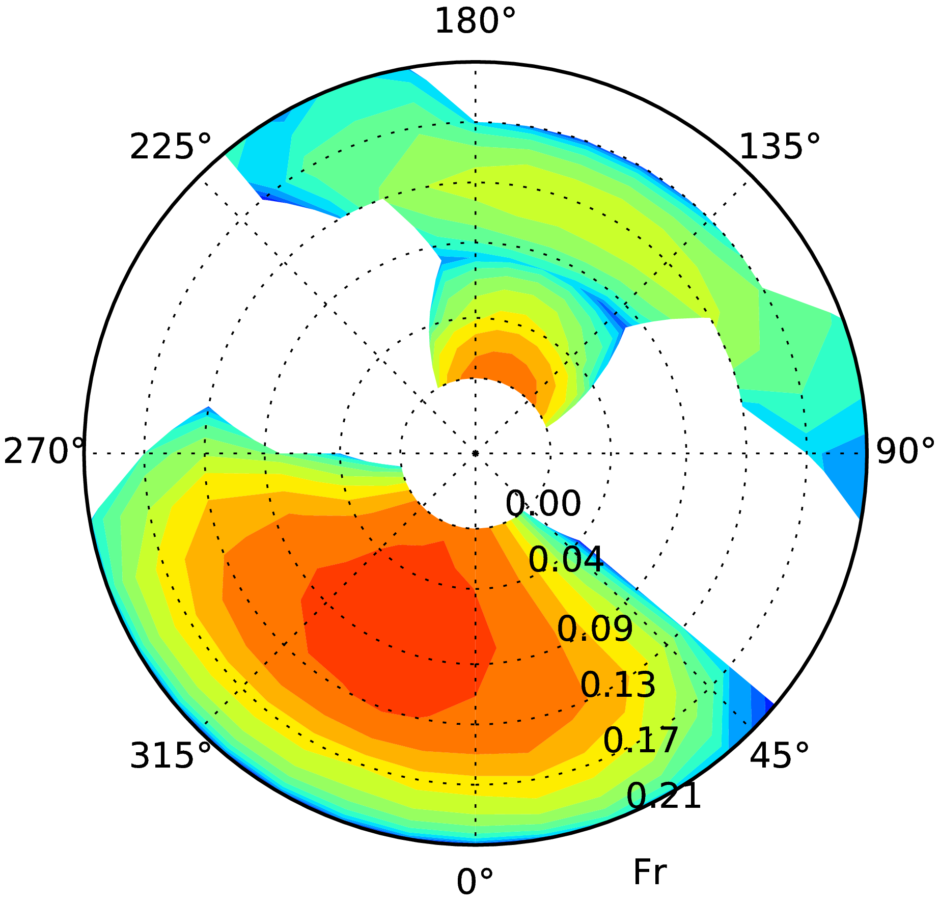 | 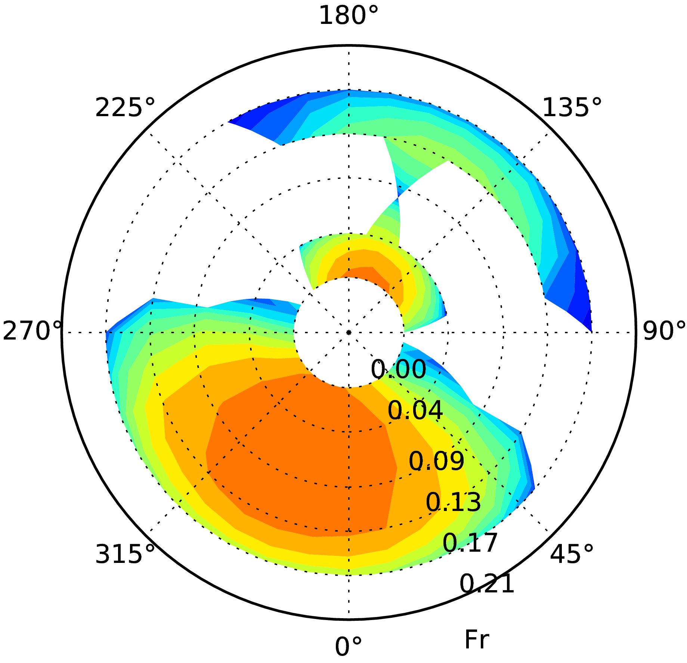
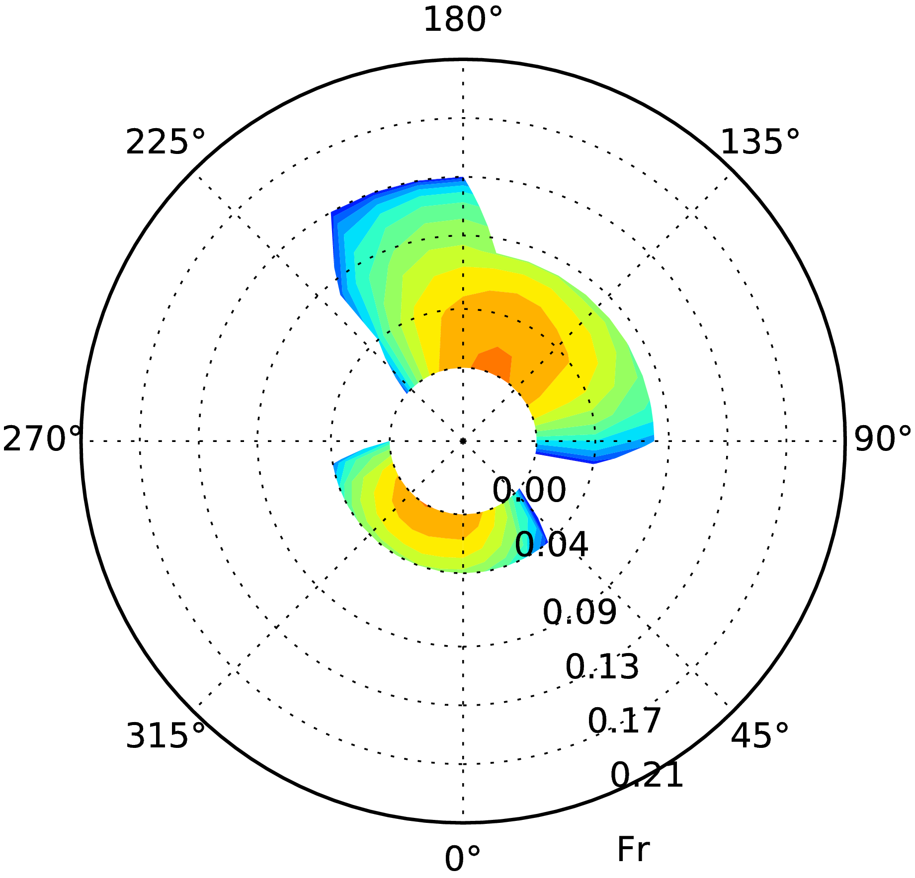 | 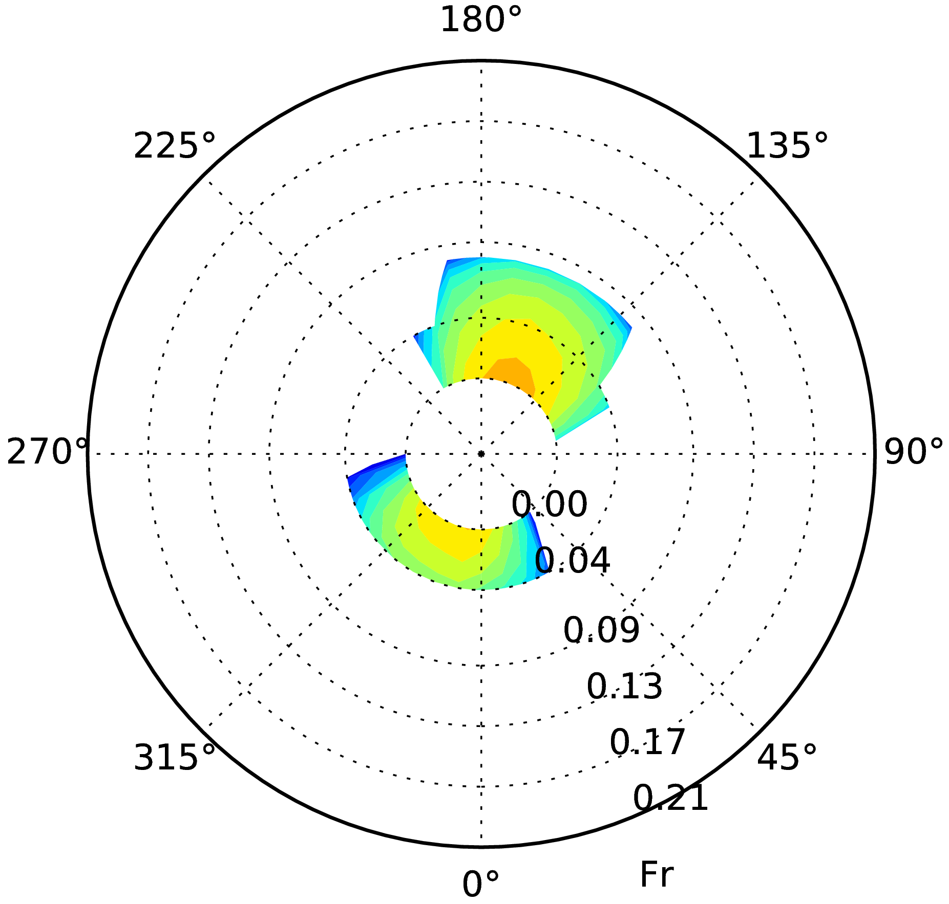 | 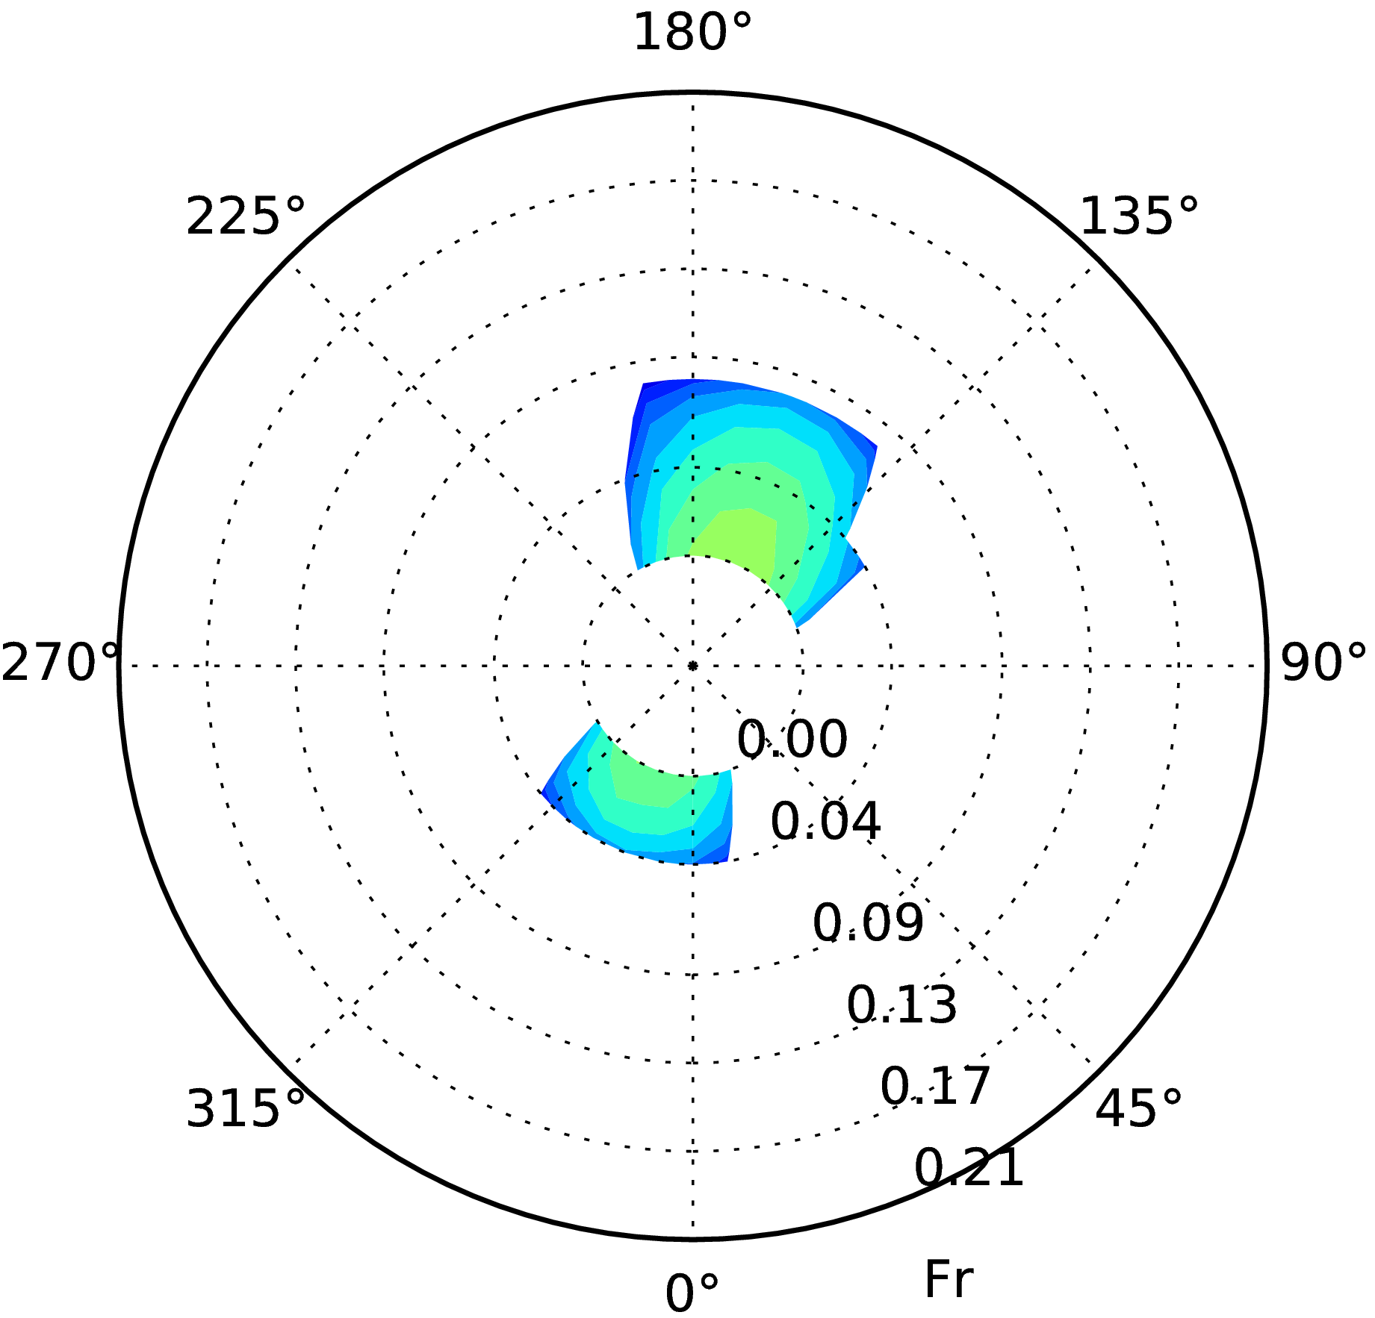
Figure 4.5 Situation B: colour plot of stability failure rate, 1/s, vs. Fr number (radial coordinate) and ship course (circumferential coordinate) for measured wave energy spectrum (left), summed rate for separate wind waves and swell wave energy spectra (middle) and summed rate for separate wind waves and swell wave energy spectra approximated with JONSWAP spectrum with γ=3.3 and cos² wave energy spreading (right) for 1700 TEU container ship in LC01 (top) and 14000 TEU container ship in LC01 (middle) and LC02 (bottom)

(4.3)

4.1.4.5 In eq. (3), is the average stability failure rate conditional on satisfying operational guidance, is the conditional probability density of the occurrence of sea state with the significant wave height h_{s}, mean wave period T₁ and mean direction μ, set to zero if a combination (h_{s},T₁,μ) is not recommended by operational guidance and equal to the probability density of sea state occurrence otherwise; is the average stability failure rate, 1/s, of a given ship in a given loading condition at a given forward speed in the sea state (h_{s},T₁,μ). The distribution of the probability density of the occurrence of sea states was defined according to IACS Rec.34 (North Atlantic wave climate).

4.1.4.6 For convenience, both the total rate of stability failures and contributions from the various stability failure modes were calculated separately. Note that synchronous rolling in beam waves at non-zero speed is also considered in operational guidance, although it is not addressed directly by SGISC.

4.1.4.7 Two probabilistic criteria were tested as possible candidates for differentiators between safe and unsafe sailing conditions: the stability failure rate r and the product r⋅p_{s}. Figure 6 shows the dependencies of the average rate of stability failures w_{OG} (total rate and contributions from various stability failure modes) on the systematically varied short-term threshold of rp_{s}, and Figure 4.7 shows the corresponding dependencies for the systematically varied short-term threshold of r.

4.1.4.8 These results prove rp_{s} as a suitable criterion to be used for operational guidance, because it leads to the same dependencies of the long-term safety level w_{OG} on the rp_{s}-threshold for all ships, loading conditions and forward speeds until saturation (i.e. when further relaxing of the threshold does not change safety level anymore); at rp_{s} of about 10⁻⁵ 1/s, the long-term safety level becomes saturated for all considered ships, loading conditions and forward speeds.

Figure 4.6 Average rate of stability failures w_{OG} (from left to right: all failure modes, parametric roll in bow waves, parametric roll in stern waves and synchronous roll) depending on rp_{s}-threshold for (from top to bottom) cruise vessel, CV 14000 TEU, CV 1700 TEU, CV 8400 TEU and RoPax; types and colours of lines differentiate loading conditions, lines of the same type and colour correspond to various forward speeds for same loading condition

Figure 4.7 Average rate of stability failures w_{OG} (from left to right: all failure modes, parametric roll in bow waves, parametric roll in stern waves and synchronous roll) depending on r-threshold for (from top to bottom) cruise vessel, CV 14000 TEU, CV 1700 TEU, CV 8400 TEU and RoPax; types and colours of lines differentiate loading conditions, lines of the same type and colour correspond to various forward speeds for same loading condition

4.1.4.9 Using directly the the stability failure rate r as a criterion leads to some spreading of the safety level for the same value of the short-term threshold between forward speeds and loading conditions for the same ship and between ships, which means that using r as the safety criterion for operational guidance will lead to spreading of the safety level provided by operational guidance between different ships and loading conditions.

4.1.4.10 An appropriately defined approach to operational guidance should provide similar safety level for all loading and sailing conditions, i.e. not allow unsafe sailing conditions while not imposing unnecessary restrictions on safe sailing conditions. To check how the proposed approach influences the safety level of different ships and loading conditions at different forward speeds, Figure 4.8 (left) shows the results as histograms of the total number of ships, loading conditions and forward speeds (normed by 1) plotted against the resulting safety level w_{OG} (right-hand plot shows the cumulative distributions based on these histograms) for rp_{s}-criterion, and Figure 9 shows the corresponding results for the r-criterion.

4.1.4.11 These figures indicate that using the rp_{s}-criterion effectively removes cases with insufficient safety level, whereas cases that were safe enough without operational guidance are not influenced. As a result, all cases influenced by operational guidance achieve very close safety level.

4.1.4.12 Using r as a criterion for operational guidance provides a similar, while slightly poorer, quality to using rp_{s}.

Figure 4.8 Left: histograms (number of ships, loading conditions and forward speeds normed on 1) having long-term safety level w_{OG}, 1/s (x axis) for various rp_{s}-threshold values (indicated in plot). Right: cumulative distributions derived from these histograms.

Figure 4.9 Left: histograms (number of ships, loading conditions and forward speeds normed on 1) having long-term safety level w_{OG}, 1/s (x axis) for various r-threshold values (indicated in plot). Right: cumulative distributions derived from these histograms.

4.1.5 Non-probabilistic operational guidance

4.1.5.1 Whereas operational guidance based on probabilistic criteria rp_{s} and r works well, its preparation requires significant computational resources. Hence, it was investigated whether operational guidance based on a simpler, non-probabilistic, criterion is a possible solution. Such non-probabilistic operational guidance is much simpler in production and approval than a probabilistic one and, besides, it can be developed using model tests. A drawback may be, however, that non-probabilistic operational guidance does not ensure consistent safety level across various ships, loading conditions and sailing conditions, thus it is difficult to ensure consistency with direct stability assessment.

4.1.5.2 On the other hand, if direct stability assessment is performed using design situations method, its results cannot be used for production of operational guidance anyway, thus operational guidance will require specific computations which are based on a different concept. Moreover, if operational guidance is simple enough in production, it may be feasible to develop it without performing direct stability assessment, i.e. directly for loading conditions failing to fulfill vulnerability assessment requirements of level 1 or level 2.

4.1.5.3 Another consideration is that although inevitably big inaccuracy of a non-probabilistic operational guidance must be compensated by its conservativeness (to keep a suitable safety level), excessive conservativeness of operational guidance is a smaller problem than excessive conservativeness of direct stability assessment: usually, operational practices are based on more conservative requirements than design assumptions.

4.1.5.4 The approach is based on the same idea as in the probabilistic operational guidance, eq. (4.3); the difference is that instead of a probabilistic criterion (stability failure rate r or product rp_{s} above), a non-probabilistic criterion is used to differentiate between safe and unsafe sailing conditions. Studies towards the development of non-probabilistic direct stability assessment methods showed that from all compared non-probabilistic criteria (standard deviation of roll angle, average roll amplitude, significant roll amplitude and 3-hour maximum roll amplitude), the latter provides the best results in direct stability assessment compared to the others; therefore, it was also used as a criterion in the non-probabilistic operational guidance.

4.1.5.5 To compute the expected maximum 3-hour roll amplitude, numerical simulations were performed in 50 realisations of the same sea state, generated by random variation of the frequencies, directions and phases of components modelling seaway. A difficulty in the application of non-probabilistic criteria is occurrence of capsizings in some realisations: in such cases, the maximum 3-hour roll amplitude could not be defined and therefore, the mean 3-hour maximum roll amplitude could not be calculated. To indicate such cases, the mean 3-hour maximum roll amplitude was set to 60 deg in plots (because in situations where capsizings did not happen, mean 3 hour maximum roll amplitude never achieved 60 deg).

4.1.5.6 Figure 4.10 shows the dependencies of the average rate of stability failures w_{OG} (total and due to various stability failure modes) on the systematically varied threshold of the mean 3 hour maximum roll amplitude. The results indicate significant scatter of the dependencies of w_{OG} on the non-probabilistic threshold between ships, loading conditions and forward speeds; saturation happens at about 30 deg of mean 3-hour maximum roll amplitude for all considered ships, loading conditions and forward speeds.

Figure 4.10. Average rate of stability failures w_{OG} (from left to right: all failure modes, parametric roll in bow waves, parametric roll in stern waves and synchronous roll) depending on threshold of mean 3-hour maximum roll amplitude for (from top to bottom) cruise vessel, CV 14000 TEU, CV 1700 TEU, CV 8400 TEU and RoPax; types and colours of lines differentiate between loading conditions, lines of the same type and colour correspond to various forward speeds for the same loading condition

4.1.5.7 To check how non-probabilistic operational guidance influences the safety level of different ships and loading conditions at different forward speeds, Figure 4.11 (left) shows histograms of the total number of ships, loading conditions and forward speeds normed by 1, plotted against the achieved safety level w_{OG} for various values of the threshold for the mean 3-hour maximum roll (right plot shows the cumulative distributions based on these histograms). Note that the results for the threshold values of 40 and 60 deg are very similar (note that cases with 60 deg maximum roll amplitude mean here such cases where at least one capsize happened in 50 simulations of 3 hour duration each).

Figure 4.11. Left: histograms of total number of ships, loading conditions and forward speeds (normed on 1) having long-term safety level w_{OG}, 1/s (x axis) for various values (indicated in plot) of threshold of mean 3 hour maximum roll amplitude. Right: corresponding cumulative distributions.

5.8 The non-probabilistic approach does not allow to fully exclude cases with insufficient safety level: in fact, strengthening of threshold from 60 to 25 deg influences little the average rate of stability failures at and below 10⁻⁷. The safety level of all cases influenced by operational guidance is broadly spreaded.

4.1.6 Definition of thresholds

4.1.6.1 To differentiate between recommendable and not recommendable combinations of the ship forward speed and course in each sea state, appropriate long-term standard (safety level) should be defined, from which the corresponding short-term acceptance thresholds for rp_{s}, r and ϕ_{3h} can be derived using the available assessment results.

4.1.6.2 To define the long-term standard, data from FSA studies for container vessels (ref. document MSC 83/INF.8), LNG carriers (MSC 83/INF.3), crude oil tankers (MEPC 58/INF.2), cruise ships (MSC 85/INF.2), RoPax (MSC 85/INF.3) and general cargo vessels (MSC 88/INF.8) were used.

4.1.6.3 Losses due to foundering are reported only for container ships and general cargo vessels (9.78⋅10⁻⁴ and 5.10⋅10⁻³ losses per ship per year, respectively). Since SGISC address not only total losses but also other stability failures, another relevant figure is the average frequency of accidents due to heavy weather, which is reported for container ships and LNG carriers as 2.64⋅10⁻³ and 3.20⋅10⁻³ accidents per ship per year, respectively. The lower of these figures is used here to define the thresholds for recommended sailing conditions: these thresholds should provide at least the same safety level.

4.1.6.4 The figure 2.64⋅10⁻³ stability failures per ship per year corresponds to the mean time to stability failure of 1/2.64⋅10⁻³=378.8 years for one ship. To relate this number to the computations performed here, note the following:

.1 In the computations, worst possible loading condition is sought for each ship: in reality, ships rarely sail in such loading conditions. To take this into account, a factor 0.1 is applied to the above time to stability failure.

.2 Assume time in port as 20% of the total design life, thus a further factor 0.8 is applied.

.3 Computations are performed here for the rather severe North Atlantic wave climate, whereas the results of FSA relate to the world-wide service. To consider a reduced time in heavy sea in reality due to this difference, apply a further reduction factor 0.2.

.4 In the computations it is assumed that a ship randomly encounters sea states according to their occurrence frequencies in the wave scatter table; in reality, however, ships use routing and heavy-weather avoidance. This is accounted for by another reduction factor 0.2.

.5 Applying the factors described in paragraphs 6.4.1 to 6.4.5 to the time to stability failure of 378.8 years gives the time to stability failure of 1.2 years, or 3.8⋅10⁷ s per ship that should be ensured by operational measures under the assumptions used here (this corresponds to required w_{OG}=2.6⋅10⁻⁸ 1/s).

4.1.6.5 To select the short-term thresholds, Figure 4.12 and Table 4.3 show the long-term stability failure rate w_{OG}, averaged over all speeds, depending on the varied rp_{s}- (left), r- (middle) and ϕ_{3h}- (right) thresholds; the results indicate 10⁻¹⁰ 1/s and 10⁻⁶ 1/s as appropriate thresholds for rp_{s} and r, respectively.

4.1.6.6 To illustrate the difficulty of the definition of the required short-term threshold for the mean 3 hour-maximum roll amplitude ϕ_{3h}, Table 4.4 shows the mean time (in hours) to stability failure, following from the rp_{s}-threshold of 10⁻¹⁰ 1/s; note that for the short-term threshold for r of 10⁻⁶ 1/s, the mean time to stability failure is about 280 hours for each sea state.

4.1.6.7 These values mean that the required exposure time for many relevant sea states significantly exceeds computational or model testing capabilities. They also mean that extrapolation of the exceedance rate over roll amplitude is unfeasible: such extrapolation needs to go too far, whereas the dependency of the exceedance probability on roll amplitude is unpredictable, Figure 4.13, and strongly depends on the form of the righting lever curve, stability failure mode and wave height, period and direction.

4.1.6.8 One practical alternative is to find a simple empirical formula for the ϕ_{3h}-threshold based on its relation with the safety level. Figure 4.12, right, shows the long-term stability failure rate w_{OG}, averaged over all forward speeds, vs. short-term ϕ_{3h}-threshold for sample ships and loading conditions, and Table 4.3 shows the resulting threshold values. Figure 4.14, comparing these values with the calm-water capsize heel angle, shows that the threshold can be approximated as half of the calm-water capsize heel (generally, as half of the heel angle defining stability failure). Although this definition appears not conservative in some cases, note that the results of probabilistic assessment used to define thresholds are conservative due to conservative extrapolation of stability failure rate over wave height: this does not matter for the definition of r- and rp_{s}-thresholds but influences the definition of ϕ_{3h}-threshold.

4.1.6.9 Another way is to use a relation following from the Rayleigh distribution of roll amplitudes, i.e. α⋅ϕ_{3h} ≤ϕ_{sf}, where ϕ_{sf} defines the stability failure, α={ln(T/T_{r})/ln(T_{3h}/T_{r})}^{0.5} (but not less than 1), T=p_{s}/10⁻¹⁰, T_{r} is the natural roll period and T_{3h} is 3 hours in seconds; Figure 4.15 shows that this approximation is suitable for synchronous roll in beam waves and conservative for parametric roll.

Figure 4.12 Long-term stability failure rate w_{OG} (averaged over all forward speeds) vs. short-term rp_{s}- (left), r- (middle) and ϕ_{3h}- (right) thresholds for different ships (rows) and loading conditions (different lines)

Table 4.3 Definition of short-term threshold for operational guidance
Ship | Loading condition | rp_{s}, 1/s | r, 1/s | ϕ_{3h},º
Cruise vessel | 01 | 1.3⋅10⁻¹⁰ | 4.7⋅10⁻⁶ | -
Cruise vessel | 02 | 4.2⋅10⁻¹⁰ | 9.7⋅10⁻⁵ | -
1700 TEU container ship | 01 | 6.5⋅10⁻¹¹ | 1.7⋅10⁻⁶ | 20.7
1700 TEU container ship | 02 | 1.1⋅10⁻¹⁰ | 5.9⋅10⁻⁶ | 29.7
8400 TEU container ship | 01 | 1.2⋅10⁻¹⁰ | 5.2⋅10⁻⁶ | 20.6
8400 TEU container ship | 02 | 1.8⋅10⁻¹⁰ | 6.1⋅10⁻⁶ | 23.6
8400 TEU container ship | 03 | 5.4⋅10⁻¹⁰ | 1.6⋅10⁻⁵ | 34.8
8400 TEU container ship | 04 | 2.7⋅10⁻¹⁰ | 2.5⋅10⁻⁵ | 33.6
CV-14000 container ship | 01 | 6.3⋅10⁻¹¹ | 1.7⋅10⁻⁶ | 7.7
CV-14000 container ship | 02 | 7.1⋅10⁻¹¹ | 2.1⋅10⁻⁶ | 17.9
CV-14000 container ship | 03 | 1.7⋅10⁻¹⁰ | 5.4⋅10⁻⁶ | -
Selection |  | 10⁻¹⁰ | 10⁻⁶ | s. text

Table 4.4 Expected time to stability failure, hours, corresponding to rp_{s}=10⁻¹⁰ 1/s

h_{s},m/T_{z},s | 3.5 | 4.5 | 5.5 | 6.5 | 7.5 | 8.5 | 9.5 | 10.5 | 11.5 | 12.5 | 13.5 | 14.5 | 15.5 | 16.5 | 17.5 | 18.5 | 19.5 | 20.5 | 21.5 | cum. h_{s},%
21.5 |  |  |  |  |  |  |  |  |  | 2 | 2 | 2 |  |  |  |  |  |  |  | 100
20.5 |  |  |  |  |  |  |  | 2 | 4 | 4 | 6 | 4 | 2 | 2 |  |  |  |  |  | 100
19.5 |  |  |  |  |  |  | 2 | 6 | 12 | 15 | 15 | 12 | 6 | 4 | 2 |  |  |  |  | 100
18.5 |  |  |  |  |  |  | 6 | 19 | 39 | 50 | 46 | 33 | 17 | 8 | 4 | 2 |  |  |  | 100
17.5 |  |  |  |  |  | 2 | 19 | 66 | 127 | 158 | 135 | 89 | 46 | 19 | 8 | 2 |  |  |  | 100
16.5 |  |  |  |  |  | 10 | 68 | 222 | 401 | 465 | 378 | 231 | 114 | 46 | 17 | 6 | 2 |  |  | 100
15.5 |  |  |  |  | 2 | 37 | 241 | 721 | 1211 | 1306 | 997 | 579 | 270 | 106 | 37 | 12 | 4 |  |  | 100
14.5 |  |  |  |  | 10 | 141 | 826 | 2255 | 3490 | 3499 | 2500 | 1368 | 606 | 226 | 73 | 21 | 6 | 2 |  | 100
13.5 |  |  |  |  | 37 | 521 | 2714 | 6728 | 9558 | 8872 | 5916 | 3040 | 1271 | 449 | 139 | 39 | 10 | 2 |  | 100
12.5 |  |  |  | 4 | 149 | 1850 | 8549 | 19109 | 24786 | 21215 | 13154 | 6331 | 2492 | 835 | 247 | 66 | 15 | 4 |  | 100
11.5 |  |  |  | 14 | 586 | 6310 | 25677 | 51404 | 60534 | 47564 | 27319 | 12274 | 4541 | 1439 | 403 | 102 | 23 | 6 | 2 | 100
10.5 |  |  |  | 64 | 2251 | 20610 | 73169 | 130216 | 138368 | 99296 | 52612 | 21989 | 7620 | 2274 | 604 | 145 | 33 | 8 | 2 | 100
9.5 |  |  | 2 | 293 | 8335 | 64130 | 196555 | 308351 | 293636 | 191381 | 93113 | 36065 | 11672 | 3275 | 822 | 187 | 41 | 8 | 2 | 100
8.5 |  |  | 10 | 1316 | 29643 | 188800 | 493673 | 676208 | 572641 | 336844 | 149720 | 53513 | 16119 | 4242 | 1003 | 218 | 44 | 8 | 2 | 99
7.5 |  |  | 54 | 5733 | 100554 | 521111 | 1146676 | 1356439 | 1012485 | 533659 | 215424 | 70716 | 19749 | 4857 | 1080 | 222 | 42 | 8 | 2 | 98
6.5 |  |  | 322 | 24242 | 322189 | 1331483 | 2426389 | 2447049 | 1593243 | 746090 | 271632 | 81429 | 20986 | 4805 | 1003 | 195 | 35 | 6 | 2 | 95
5.5 |  | 2 | 1927 | 98437 | 961333 | 3092058 | 4576869 | 3874012 | 2172126 | 894226 | 291080 | 79115 | 18704 | 3968 | 774 | 141 | 25 | 4 |  | 90
4.5 |  | 29 | 11483 | 378318 | 2612429 | 6343403 | 7441018 | 5180330 | 2459753 | 877866 | 252498 | 61607 | 13248 | 2585 | 469 | 81 | 14 | 2 |  | 82
3.5 |  | 336 | 67398 | 1341645 | 6223835 | 10946988 | 9836167 | 5474477 | 2149059 | 651393 | 162654 | 35085 | 6773 | 1202 | 201 | 31 | 6 |  |  | 69
2.5 | 2 | 4159 | 380887 | 4164313 | 12017671 | 14370011 | 9375594 | 3985204 | 1243154 | 309113 | 64986 | 12058 | 2039 | 322 | 48 | 8 | 2 |  |  | 49
1.5 | 62 | 56539 | 1902020 | 9598645 | 14926494 | 10743858 | 4582654 | 1356960 | 310031 | 58789 | 9743 | 1464 | 204 | 27 | 4 |  |  |  |  | 26
0.5 | 2514 | 258034 | 1670195 | 2288538 | 1223833 | 359473 | 71188 | 10820 | 1375 | 154 | 15 | 2 |  |  |  |  |  |  |  | 3

Figure 4.13. Cumulative distributions of exceedance rate vs. roll amplitude for (from left to right then top to bottom) cruise vessel in loading condition LC01 (examples of parametric roll in head and following waves and synchronous roll in beam waves), 1700 TEU container ship in LC01 (parametric roll in head and following waves) and LC02 (synchronous roll in beam waves) and 8400 TEU container ship in LC01 (parametric roll in head and following waves)

Figure 4.14. ϕ_{3h}-threshold vs. calm-water capsize heel angle

Figure 4.15. vs. for parametric roll in stern-quartering (,) and bow (,) waves and synchronous roll (,); blue dashed lines show Rayleigh distribution

4.1.6.10 Figure 4.16 shows examples mean 3 hour-maximum roll amplitude, its double value and maximum roll amplitude, defined from 15 hour simulations of several typical parametric and synchronous roll situations, vs. significant wave height, and Figure 4.17 shows the corresponding results using factor α. The results indicate that doubling ϕ_{3h} produces slightly more conservative results than using factor α, and both provide the limiting significant wave height of 1 to 2 m less than that leading to capsizing in 3 hours.

Figure 4.16 Mean 3-hour maximum roll amplitude defined excluding capsizing events (), its double value (solid line), maximum roll amplitude taking () and not taking () into account capsizes and calm-water capsize heel (horizontal dashed line) vs. significant wave height for parametric roll in following (0º) and head (180º) waves and synchronous roll in beam (90º) waves: for several ships and loading conditions

4.1.6.11 Table 4.5 shows conservative and non-conservative errors (defined as the percentage of the number of situations with conservative or non-conservative errors from the total number of situations) of non-probabilistic operational guidance based on 2ϕ_{3h}-criterion vs. probabilistic operational guidance based on rp_{s}-criterion; Figure 4.18 compares the resulting non-recommended sailing situations (shown in red).

4.1.7 Simplified operational guidance

4.1.7.1 Operational guidance provides detailed recommendations regarding ship’s forward speed and course and therefore, requires accurate methods (numerical or experimental) of the level corresponding to direct stability assessment. However, sometimes coarse conservative recommendations for the forward speed and course, provided by simpler means, are sufficient for the ship owner and acceptable for the Administration.
Figure 4.17 Mean 3-hour maximum roll amplitude (), its value multiplied with factor (solid line), maximum roll amplitude taking () and not taking () into account capsizes and calm-water capsize heel (horizontal dashed line) vs. significant wave height for parametric roll in following (0º) and head (180º) waves and synchronous roll in beam (90º) waves for several ships and loading conditions

Table 4.5 Percentage of conservative and non-conservative errors of non-probabilistic operational guidance compared to probabilistic operational guidance
Ship | Cruise | CV 1700 TEU |  | CV 8400 TEU
LC | LC01 | LC01 | LC02 | LC01 | LC03
Non-conservative | 2.4 | 1.6 | 2.5 | 3.5 | 2.1
Conservative | 4.1 | 9.9 | 5.6 | 1.6 | 0.0

4.1.7.2 For example, level 1 or level 2 criteria from the Guidelines for vulnerability assessment can be used for some failure modes:

.1 for the pure loss and surf-riding/broaching stability failure modes, operational limitation (i.e. maximum recommended significant wave height) defined with level 2 vulnerability criteria can be efficiently combined with the forward speed limit according to level 1 vulnerability criteria in following and stern-quartering seaways at greater significant wave heights;

.2 for excessive accelerations, where the level 2 vulnerability assessment is performed at zero forward speed, forward speed effect can be added to level 2-based operational limitations in a conservative way.
Figure 4.18. Examples of probabilistic (top) and non-probabilistic (bottom) operational guidance in axes ship speed (in knots, radial coordinate) – mean wave direction (circumferential coordinate) at different significant wave heights (columns) for 1700 TEU (three left columns) and 8400 TEU (three right columns) container ships

4.1.7.3 Check 2 of level 2 parametric roll criterion provides dependency of roll motion characteristics on the forward speed, hence it is useful to check whether this dependency is sufficiently accurate for a simplified operational guidance. Here, the sensitivity of this criterion to changes in forward speed is compared with direct stability assessment results.

4.1.7.4 According to this criterion, a loading condition is considered not vulnerable to parametric roll stability failure mode if , where and refer to sailing in head and following waves, respectively, at a Froude number Fr_{j} and are calculated for each of Fr_{j} as a sum over all N sea states of a scatter table as ; w_{i} is the normed probability density of a sea state i and c_{i}=1 when roll amplitude exceeds 25º and 0 otherwise.

4.1.7.5 To verify whether criteria can be used for forward speed recommendations, their dependency on the forward speed for all sample ships in all loading conditions was compared with the dependency on forward speed of the mean rate of stability failures due to parametric roll obtained from direct stability assessment separately in head (denoted as ) and following () waves.

4.1.7.6 For comparison, 40, 25 and 15º heel angles were used as definition of stability failure. Figure 4.19 shows (left y axis) and (right y axis) vs. Fr (x axis) for 15 (left), 25 (middle) and 40 (right) deg definitions for different loading conditions (differentiated with lines of the same type: those with symbols refer to direct assessment result and those without symbols to check 2 of level 2 result ) of sample ships (each ship corresponds to one row). Figure 20 shows corresponding results for parametric roll in following waves.
Figure 4.19. Parametric roll in head waves: direct assessment result (left y axis) and check 2 of level 2 result (right axis) vs. Fr (x axis) for 15 (left), 25 (middle) and 40 (right) degree definition of stability failure for all loading conditions; each line corresponds to one loading condition: black lines with symbols refer to , same type blue lines without symbols to

4.1.7.7 The results indicate that check 2 of level 2 parametric roll criterion produces in general good results at low GM; with increasing GM, the agreement worsens: this criterion indicates that large roll amplitudes move to higher forward speed or disappear, thus parametric roll becomes not dangerous at low forward speeds, whereas direct simulations indicate persistent danger of parametric roll at low forward speeds (with the exception of RoPax, for which failure rate due to parametric roll is always very small). The agreement between check 2 of level 2 and direct simulation improves for 40º heel angle as a failure criterion instead of 25º and worsens for 15º.
Figure 4.20. Parametric roll in following waves: direct assessment result (left y axis) and check 2 of level 2 result (right axis) vs. Fr (x axis) for 15 (left), 25 (middle) and 40 (right) degree definition of stability failure for all loading conditions; each line corresponds to one loading condition: black lines with symbols refer to , same type blue lines without symbols to

4.1.7.8 To check the reason for this difference, Figure 4.21 and Figure 4.22 show failure rate due to parametric roll in head waves together with roll amplitude according to check 2 of level 2 criterion depending on Fr for 8400 TEU container ship, for which the differences between check 2 of level 2 and direct assessment in Figure 4.19 and Figure 4.20 are the largest, in three loading conditions with the smallest GM values at three significant wave heights and various mean wave periods. The figures indicate that the dependency of roll motions on forward speed differs between check 2 of level 2 criterion and direct simulations.

4.1.7.9 These results suggest that, first, using check 2 of level 2 parametric roll criterion to provide forward speed recommendations requires further validation and eventually improvement of this criterion; and, second, that direct stability assessment for parametric roll in head waves can be conducted at zero (or as small as practicable) forward speed.
Figure 4.21. Failure rate due to parametric roll in head waves (left y axis, black lines with symbols) and roll amplitude from check 2 of level 2 PR criterion (right y axis, blue lines without symbols) vs. Fr (x axis) for 8400 TEU container ship in three loading conditions (each row corresponds to one loading condition) at significant wave height of (from left to right) 4, 8 and 12 m; different lines correspond to different wave periods

Figure 4.22. Failure rate due to parametric roll in following waves (left y axis, black lines with symbols) and roll amplitude from check 2 of level 2 PR criterion (right y axis, blue lines without symbols) vs. Fr (x axis) for 8400 TEU container ship in three loading conditions (each row corresponds to one loading condition) at significant wave height of (from left to right) 4, 8 and 12 m; different lines correspond to different wave periods
4.1.7.10 Model test results in Figure 4.23 confirm that in irregular waves, low forward speeds are more critical for parametric roll in head waves than higher forward speeds, even if resonance condition suggests that higher forward speed should be more critical (compare with Figure 4.24 which relates to parametric resonance in regular head waves).

Figure 4.23 Measured () and computed () RMS of roll angle (y axis) in irregular head waves vs. Fr (x axis) and wave period (one wave period per plot) | Figure 4.24 Measured (,) and computed () roll amplitude (y axis) in regular head waves vs. Fr (x axis) and wave period (one wave period per plot)

4.1.8 When operational limitations or operational guidance may not be sufficient

4.1.8.1 Obviously, application of operational limitations or operational guidance can reduce the mean stability failure rate to any specified level; thus, any loading condition of any ship can be made “sufficiently safe” using sufficiently strict operational limitations or operational guidance. However, if too many combinations of ship speed and course in too many sea states should be excluded as unsafe for some loading condition, it cannot be considered as safe in routine practical operation. Thus, if the total amount of safe sailing conditions becomes too small for some loading condition, it cannot be considered as allowed even when operational limitations or operational guidance is provided.

4.1.8.2 It follows from these considerations that a suitable criterion to distinguish between those loading conditions for which operational limitations or operational guidance is a suitable measure from those which cannot be allowed even with operational limitations or operational guidance, is the total duration of recommende sailing conditions (defined by wave height, period and direction and forward ship speed) according to operational limitations or operational guidance as percentage from the total operational life at sea; such percentage is frequently referred to as operability.

4.1.8.3 Similarly to other criteria, the standard for operability can be defined from case studies. Figure 4.25 shows the average stability failure rate w_{OG} depending on the applied rp_{s}-threshold, operability plotted as a function of rp_{s}-threshold and the average stability failure rate plotted as a function of operability for different ships, loading conditions and forward speeds. For rp_{s}-threshold equal to 10⁻¹⁰ 1/s and the maximum acceptable long-term mean stability failure rate of 2.6⋅10⁻⁸ 1/s, the minimum value of operability over all considered ships and loading conditions is about 0.7. Removing the worst case leads to the value 0.8 as appropriate for the operability standard to eliminate loading conditions for which operational limitations or operational guidance is not a sufficient alternative.
Figure 4.25 Left: mean long-term stability failure rate w_{OG} vs. rp_{s}-threshold, middle: operability vs. rp_{s}-threshold, right: mean stability failure rate vs. operability for (from top to bottom) cruise vessel, CV 14000 TEU, CV 1700 TEU and RoPax; curves of the same colour refer to the same loading condition, curves of the same style refer to the same forward speed

4.1.8.4 Figure 4.26 shows similar dependencies for a non-probabilistic operational guidance: mean long-term stability failure rate w_{OG} depending on the short-term threshold of the mean 3-hour maximum roll amplitude, operability as a function of the threshold of the mean 3-hour maximum roll amplitude and mean long-term rate of stability failures as a function of operability for different ships, loading conditions and forward speeds.

4.1.9 Influence of propulsion, steering and seakeeping

4.1.9.1 So far, propulsion and steering abilities of a ship, as well as such seakeeping problems as excessive vertical motions and accelerations and excessive loads at high forward speed in bow waves, have not been considered in design assessment and operational measures concerning dynamic stability. For some stability failure modes, this can lead to non-conservative errors in design assessment or misleading operational recommendations. In particular,

.1 For pure loss of stability and surf-riding/broaching stability failures, which are relevant in stern waves, consideration of propulsion and steering abilities and seakeeping problems is not critical for dynamic stability.
Figure 4.26 Left: mean long-term stability failure rate w_{OG} vs. threshold of mean 3-hour maximum roll amplitude; middle: operability vs. short-term threshold of mean 3-hour maximum roll amplitude; right: mean stability failure rate vs. operability for (from top to bottom) cruise vessel, CV 14000 TEU, CV 1700 TEU and RoPax; colours and line styles differentiate loading conditions and forward speeds, respectively

.2 Dead ship condition stability failure is relevant only at zero forward speed in beam seaway, therefore these problems are also not critical.

.3 For excessive acceleration stability failure, achievable forward speed in beam seaway rather moderately influences roll motion (due to decreasing roll damping with decreasing forward speed); this does not influence the design assessment (which is performed at zero forward speed) but has a moderate influence on operational guidance. More important issue for the operational guidance is the course-keeping ability in bow seaways: if the ship is not able to avoid excessive roll motions because it cannot steer into seaway, this needs to be considered in the operational guidance.

.4 For parametric roll in bow waves, neglecting propulsion, steering and seakeeping abilities can lead to over-estimation of ship’s safety in the design assessment (if safe but unattainable ship’s speed and course combinations contribute as possible) and to dangerous situations in terms of operational guidance (when attainable ship’s speed and course combinations in a storm are not recommended, whereas all recommended combinations are found unattainable only in the storm).
4.1.9.2 Figure 4.27 shows colour plot of roll amplitude depending on forward speed and course together with the line of maximum attainable speed (solid black line) and line of maximum available steering effort (yellow dashed line) for the 8400 TEU container ship in three loading conditions. In bow waves, majority of forward speeds that lead to small roll motions are unattainable due to added resistance in seaway. Note that this observation is confirmed by experience: all parametric roll accidents in bow waves happen at a low forward speed.

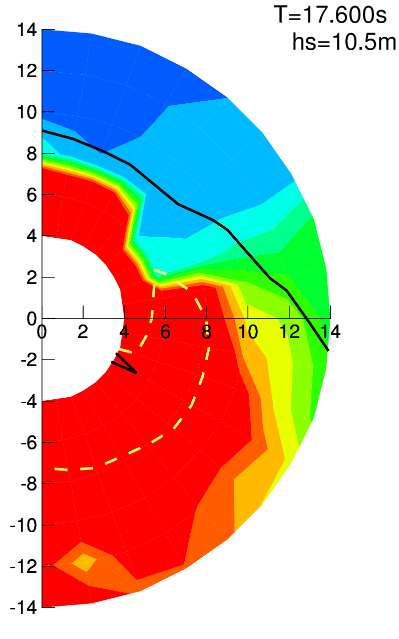 | 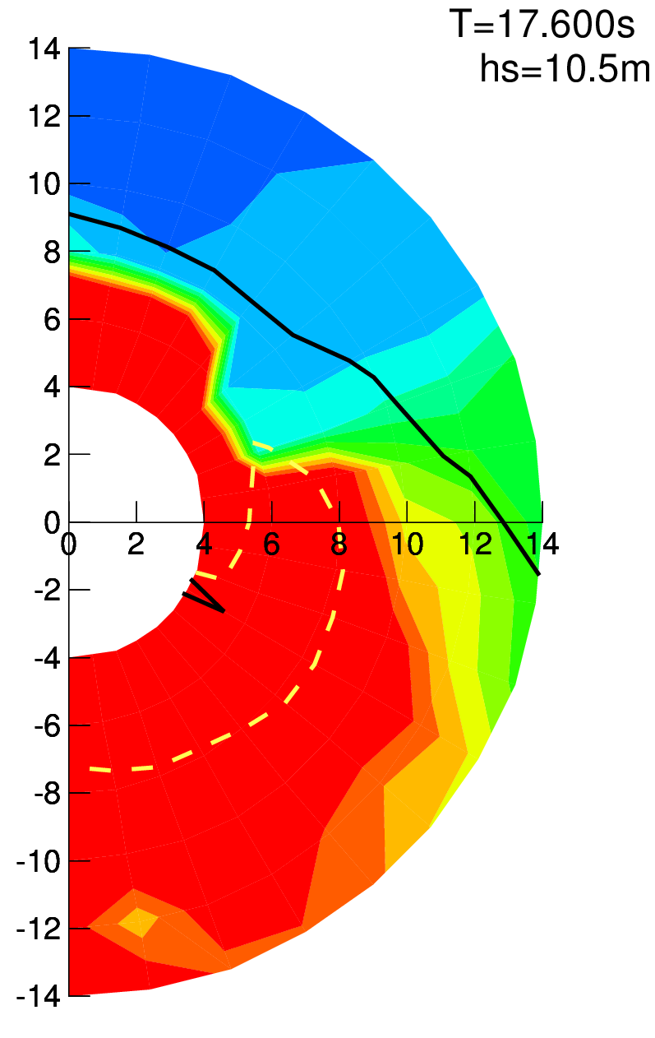 | 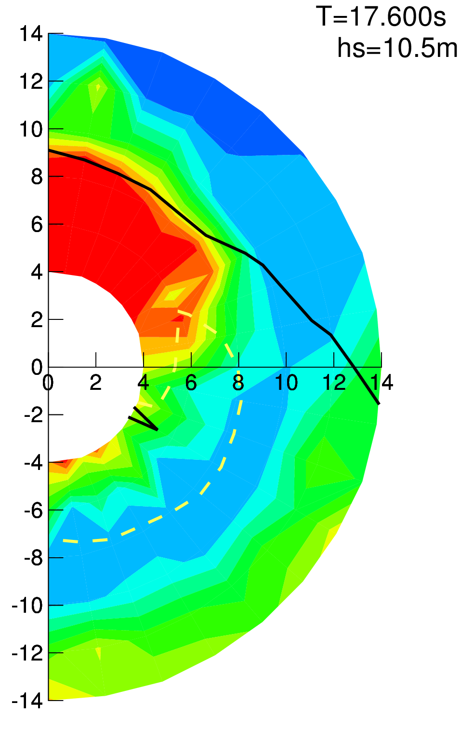
Figure 4.27. Colour plot of mean 3 hour maximum roll amplitude depending on forward speed (m/s, radial coordinate) and wave direction (circumferential coordinate, head waves at the top) for 8400 TEU container ship in loading conditions (from left to right) LC01, LC02 and LC03 together with line of maximum attainable speed (black solid line) and maximum available steering effort (yellow dashed line)

4.1.9.3 To estimate the influence of propulsion ability on parametric roll in head waves, average (over all significant wave heights and wave periods) rate of parametric roll stability failures in head waves was calculated with and without considering maximum attainable speed in head waves. In both cases, the forward speed was applied that minimises the stability failure rate, but in the calculations taking into account propulsion ability, the range of speeds was restricted by the requirement that the required engine power should not exceed the available power. Figure 4.28 shows the result as the rate of stability failures considering speed limit plotted depending on the rate of stability failures without considering speed limit.

Figure 4.28. Rate of parametric roll stability failures in head waves considering (y axis) and not considering (x axis) attainable forward speed for three container ships (different symbols) in three loading conditions each

4.1.9.4 The results show that the rate of stability failures increases by several orders of magnitude if propulsion ability is considered. This means,

.1 in terms of stability assessment, that assessment at zero forward speed in head waves is a realistic assumption; and

.2 in terms of operational guidance, that propulsion ability should be considered in operational guidance to prevent from misleading operational recommendations.

4.1.9.5 The attainable forward speed can be defined from model tests or numerical computations; alternatively, a simple empirical formula can be established.

4. 2 Wave cases for wave cases for preparation of operational limitations using level 1 and level 2 vulnerability assessment

4.2.1 Wave scatter diagram should have a resolution of at least 1 s for the mean zero-upcrossing wave period and 1 m for significant wave height. For each mean zero-upcrossing wave period in the scatter table,

.1 the reference wave height h_{ref,i} is selected as the conditional mean significant wave height; and

.2 the corresponding reference wave period T_{ref,i} is selected as the corresponding mean spectral period: for the Bretschneider spectrum, T_{mean}=1.0864⋅T_{z}.

4.2.2 The result is a series of reference environmental conditions T_{ref,i},h_{ref,i} with i=1,…N, where N is the number of wave periods in the wave scatter table.

4.2.3 Each reference environmental condition is associated with the probability density w_{i}, which is obtained from the wave scatter table as the sum of the probabilities of all sea states with the reference wave period T_{ref,i}.

4.2.4 The sets of N wave cases are selected separately for parametric roll and pure loss of stability starting from the obtained set of reference environmental conditions and using the following equivalence formulae:

.1 For parametric roll: wave length and wave height with ;

.2 For pure loss of stability: wave length and wave height , where .

4.2.5 The first check of Level 2 vulnerability assessment for parametric roll is carried out using waves defined in 2.5.3 of the Guidelines.

4.2.6 Level 1 vulnerability assessment is performed using the following conservative values for the wave steepness parameter:

.1 For parametric roll: ;

.2 For pure loss of stability: ;

4.2.7 Level 2 vulnerability assessments using directly data from the wave scatter table can be applied by substituting the standard wave scatter diagram with the wave scatter diagram associated with the considered operational restrictions or operational limitations.

4.3 Supplementing information on calculation for simplifying operational guidance for surf-riding/broaching failure mode

4.3.1 For predicting surf-riding/broaching, accurate estimation of the wave-induced surge force is indispensable. In case of level 2 vulnerability criterion for surf-riding/broaching in 2.6.3.4.5, the Froude-Krylov component is taken into account. The Froude-Krylov component on its own normally overestimates the wave-induced surge force under the situation relevant to surf-riding. This is because the diffraction component, which is the effect of hull disturbance on incident waves is not small. Thus, the diffraction effect should be taken into account for practical use on-board.

4.3.2 It could be estimated with CFD or three-dimensional linear potential flow code but, considering the request of simplified guidelines, the following empirical formula of f_{ij}, in place of that in 2.5.3.3.1, could be used as an alternative to CFD or equivalent:

Here the coefficient, μ_{x}, based on the experimental data of the two containership, the car carrier, a RoRo ship, a fishing vessel and two war ships is as follows:

where C_{b}: block coefficient and C_{m}: midship section coefficient.

___________

